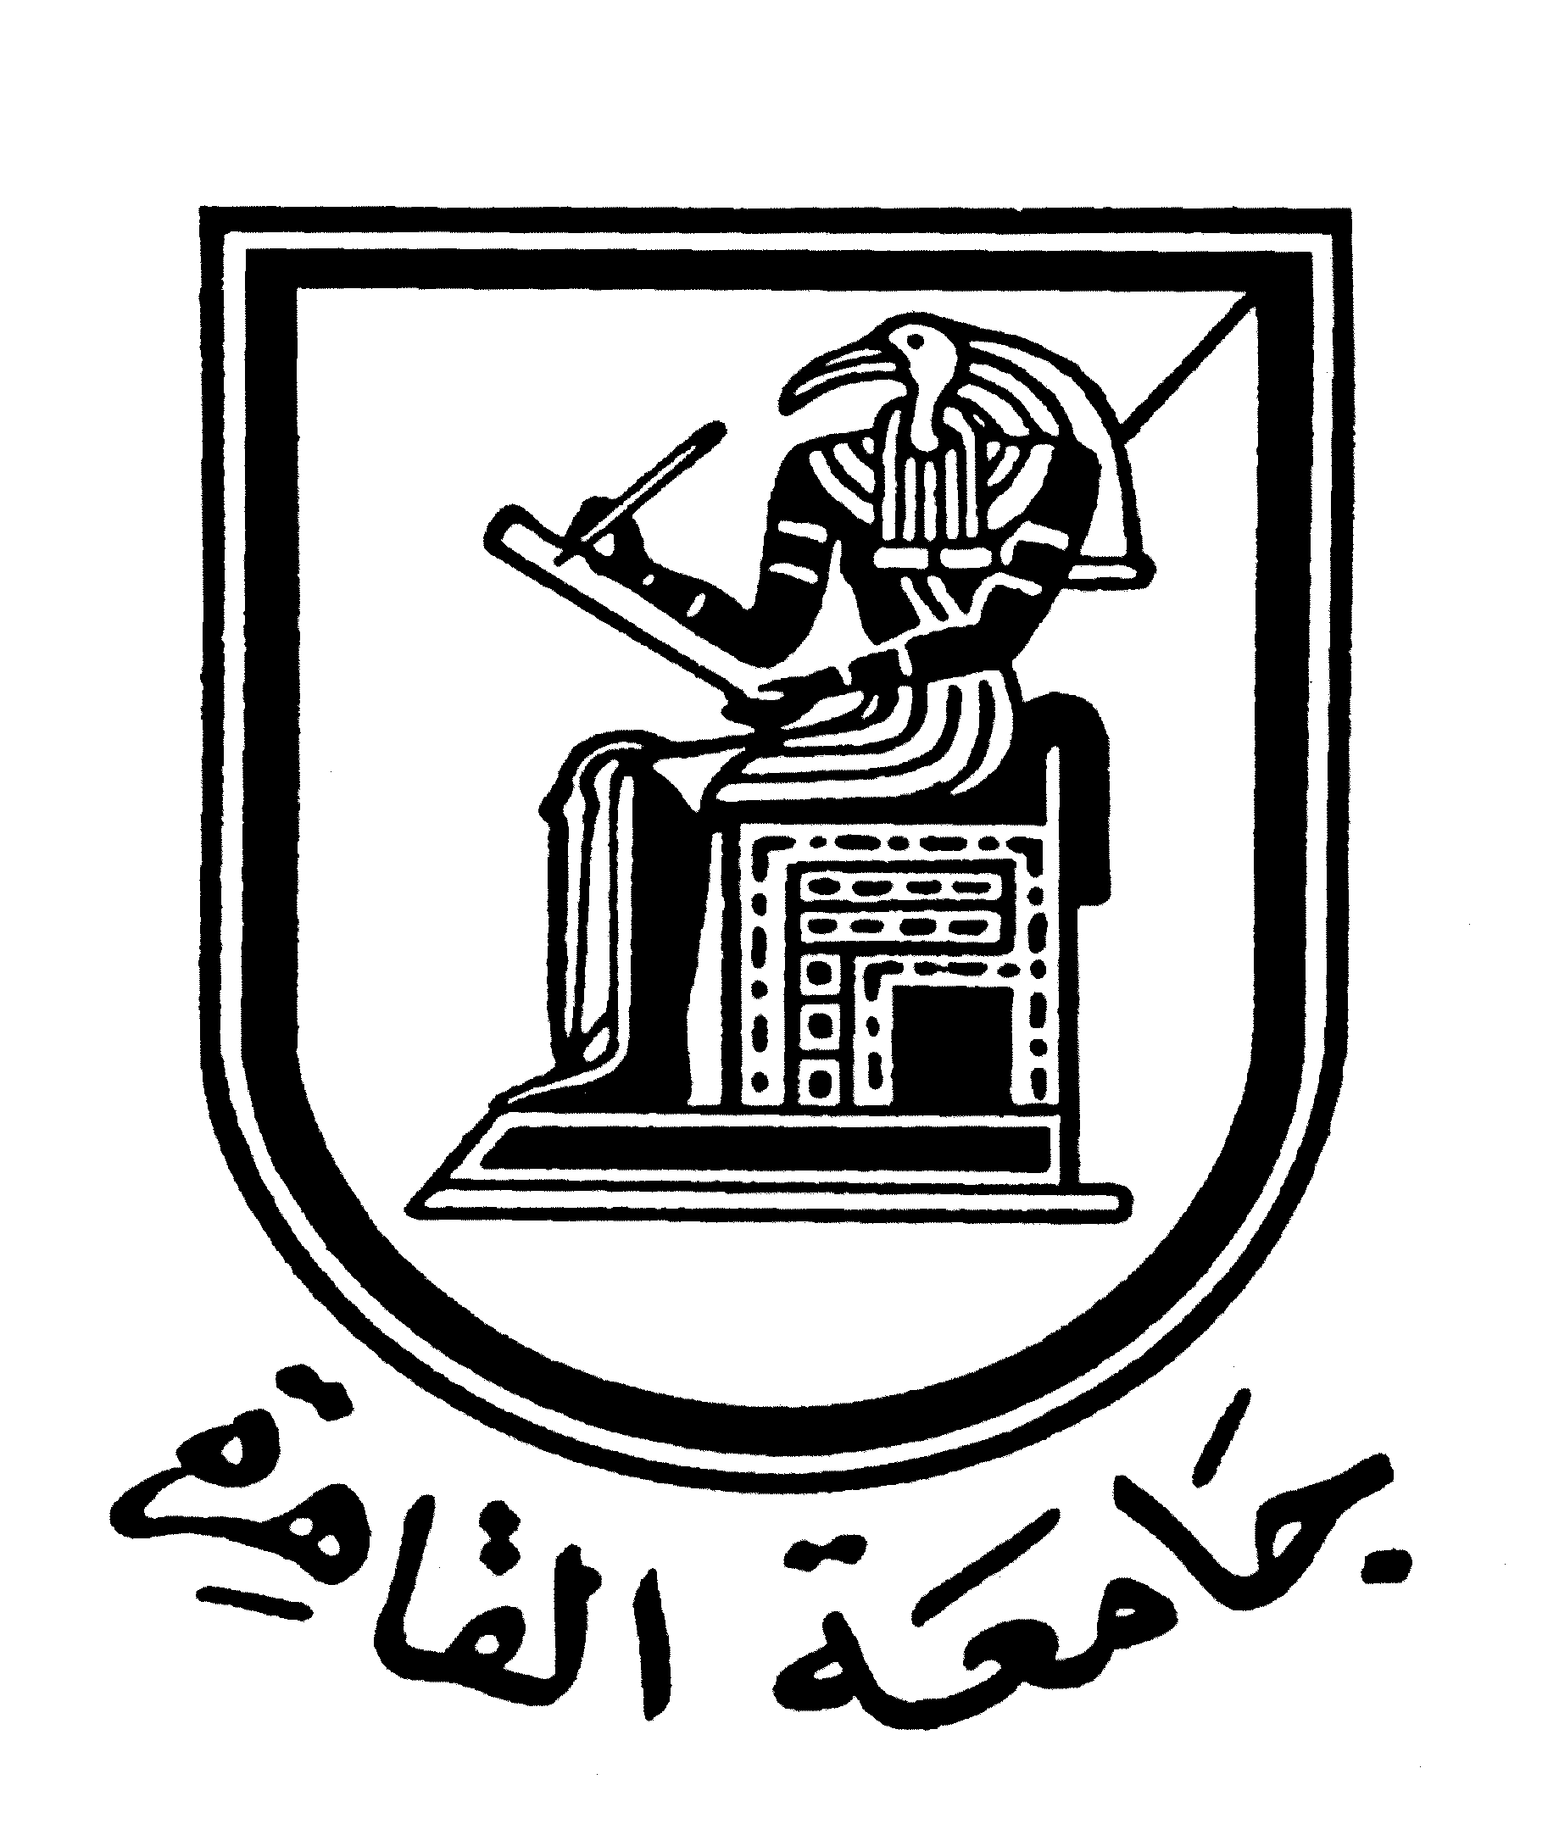 |  | 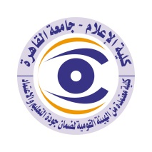

Curriculum Vitae CV (brief) for faculty members
- Name: Howayda Syed Mustafa
Academic Department: Radio and TV
Academic Degree: Professor
2- The title of the master's thesis, the year and the authority where it was obtained:
Master’s degree in Mass Communication from the Radio Department, Faculty of Mass Communication/Cairo University, entitled “Values Reflected by Commercial Network Advertisements and their Relationship with development agenda: An analytical study on a sample of Middle East Radio advertisements, with excellent grades. (1980 - 1984).
3- The title of the PHD thesis, the year and authority where it was obtained:
Ph.D. in Mass Communication from the Radio Department at the Faculty of Mass Communication/Cairo University entitled “News Handling of Arab Issues and Affairs on Egyptian TV”: An applied study on the Gulf crisis, with first honors.
4-Courses you teach in undergraduate programs:

5-The most important reference books issued to you benefiting from your scientific research (not exceed five books).
Advertising in Contemporary Media Systems, Cairo, Atlas for Publishing and Media Production, 2017
Editing and supervising the regional guide “Media and Arab Civil Society”, “The Arab Network Program for Freedom of Association”, the Arab Media Forum for Environment and Development, and the International Center for Media and Development, September 2012.
- “Media professionals and elections: Professional and Ethical Code” Training Guide for Media and Journalists for Election Coverage, first edition November 2010, and second edition October 2011, Cairo, Al-Ahram Foundation
- Media and Contemporary Crises, Cairo, Dar Al-Mahrousa Misr 2008 and reprinted through the "Family Project library", Social Sciences Series, at the Egyptian General Book Authority 2009.
The role of media in international crises, El Mahrousa Center for Research, Training and Publishing, January 2000
Advertising in Contemporary Media Systems, Cairo, Egyptian-Lebanese Publishing House, September 1999.

6- The most recent five scientific research published by me:

The credibility of media as seen by the elite in Egypt: A case study of media coverage of the war on Iraq, The Egyptian Journal for Media Research, Faculty of Mass Communication, Cairo University, October-December 2003.
The role of Arab satellite channels in being aware of political reform issues in light of a sample of journalists and media professionals' opinions. The Egyptian Journal of Public Opinion Research, edition 21, Al-Azhar University, January 2004.
Trends of news processing of Arab events and issues on Al-Hurra channel: A study on a sample of news bulletins, the Egyptian Journal of Public Opinion Research, Volume 5, Faculty of Mass Communication, Cairo University, June-December 2004.
The news processing of the war events on Iraq in the Arab satellite channels: An evaluation study, the first scientific conference of the International Academy of Media Sciences, entitled: Arab satellite channels and the changes of the era, July 2004 AD, Cairo: The Egyptian Lebanese House, January 2005.
- “The role of Arab satellite channels in shaping the public’s knowledge and attitudes toward terrorism: A field study on a sample of the Arab public, Tunisia, Arab Broadcasting Union, August 2007.
7- The most recent five researches (Master's and Ph.D.) which I have supervised:
- Nawal Askar, “The Emirati public’s dependence on social media and Arab news channels specialized in obtaining information related to the Arab revolutions” (Registration date: 15/5/2014) Ph.D. thesis
- Ali Abbas Fayyad, “The Role of Satellite Channels in Shaping Iraqi Public Opinion Attitudes towards Iraqi Political Issues” (Registration date: 17/3/2014) Master's Thesis
- Rana Mostafa Hanafi, “University Youth’s Uses and Evaluation of YouTube Channels in Egypt” (Registration date: 15/5/2014) Ph.D. thesis
- Nada Ahmed Hassan, “The Egyptian public’s relationship with human social programs and their role in spreading the idea of social solidarity” (Registration date: 18/9/2013) and the discussion on 30/3/2017 Master’s thesis
- Mansour Hammoud Muhammad al-Muntasir, “Satellite channels and websites processing for issues of the modern civil state and the public’s right attitudes towards it” (Registration date: 12/12014) Ph.D. thesis
8- The activities I carry out in the college (other than teaching) that contribute to developing the educational process as well as serving students
- Member of the Committee for the Preparation of the Media Honor Code emanating from the Media Syndicate, May 2017
- Chairman of the Media Club Award for Journalistic Excellence organized by the Danish Institute for Dialogue March 8/2/2017 until now
- Member of the National Committee for Media and Press Legislation in charge of preparing the unified draft act regulating the press and media, August 2015 until March 2016
- Member of the Unified Examinations Committee at the Radio and Television Union 6/1/2016
- Member of “Monitoring, Follow-up and Evaluation Committee of Media and Advertising for Parliamentary Elections” after the June 30 Revolution, October 2015
- Member of the Monitoring, Follow-up and Evaluation Committee for the Media and Advertising Campaigns for the Presidential Elections after the June 30 Revolution, May 2014
- Member of the “Media Committee” of the Supreme Council of Culture at the Ministry of Culture 2014

9 The most important academic leadership positions that I held:
Professor in Radio Department, Faculty of Mass Communication, Cairo University, as of November 30, 2005
Director of the Training, Documentation and Media Production Center at the Faculty of Mass Communication, Cairo University as of October 25, 2011
Head of Radio Department, Faculty of Mass Communication, Cairo University, from 1/8/2012 to 7/31/2014
Dean of the Higher International Institute for Media in El-Shorouk from October 2014 to June 19 2017
10-The most important local and international awards that I have obtained, the year and the destination of the grants:

Communication means
Email: howaydasm@mail.com
Mobile: 01223159096

