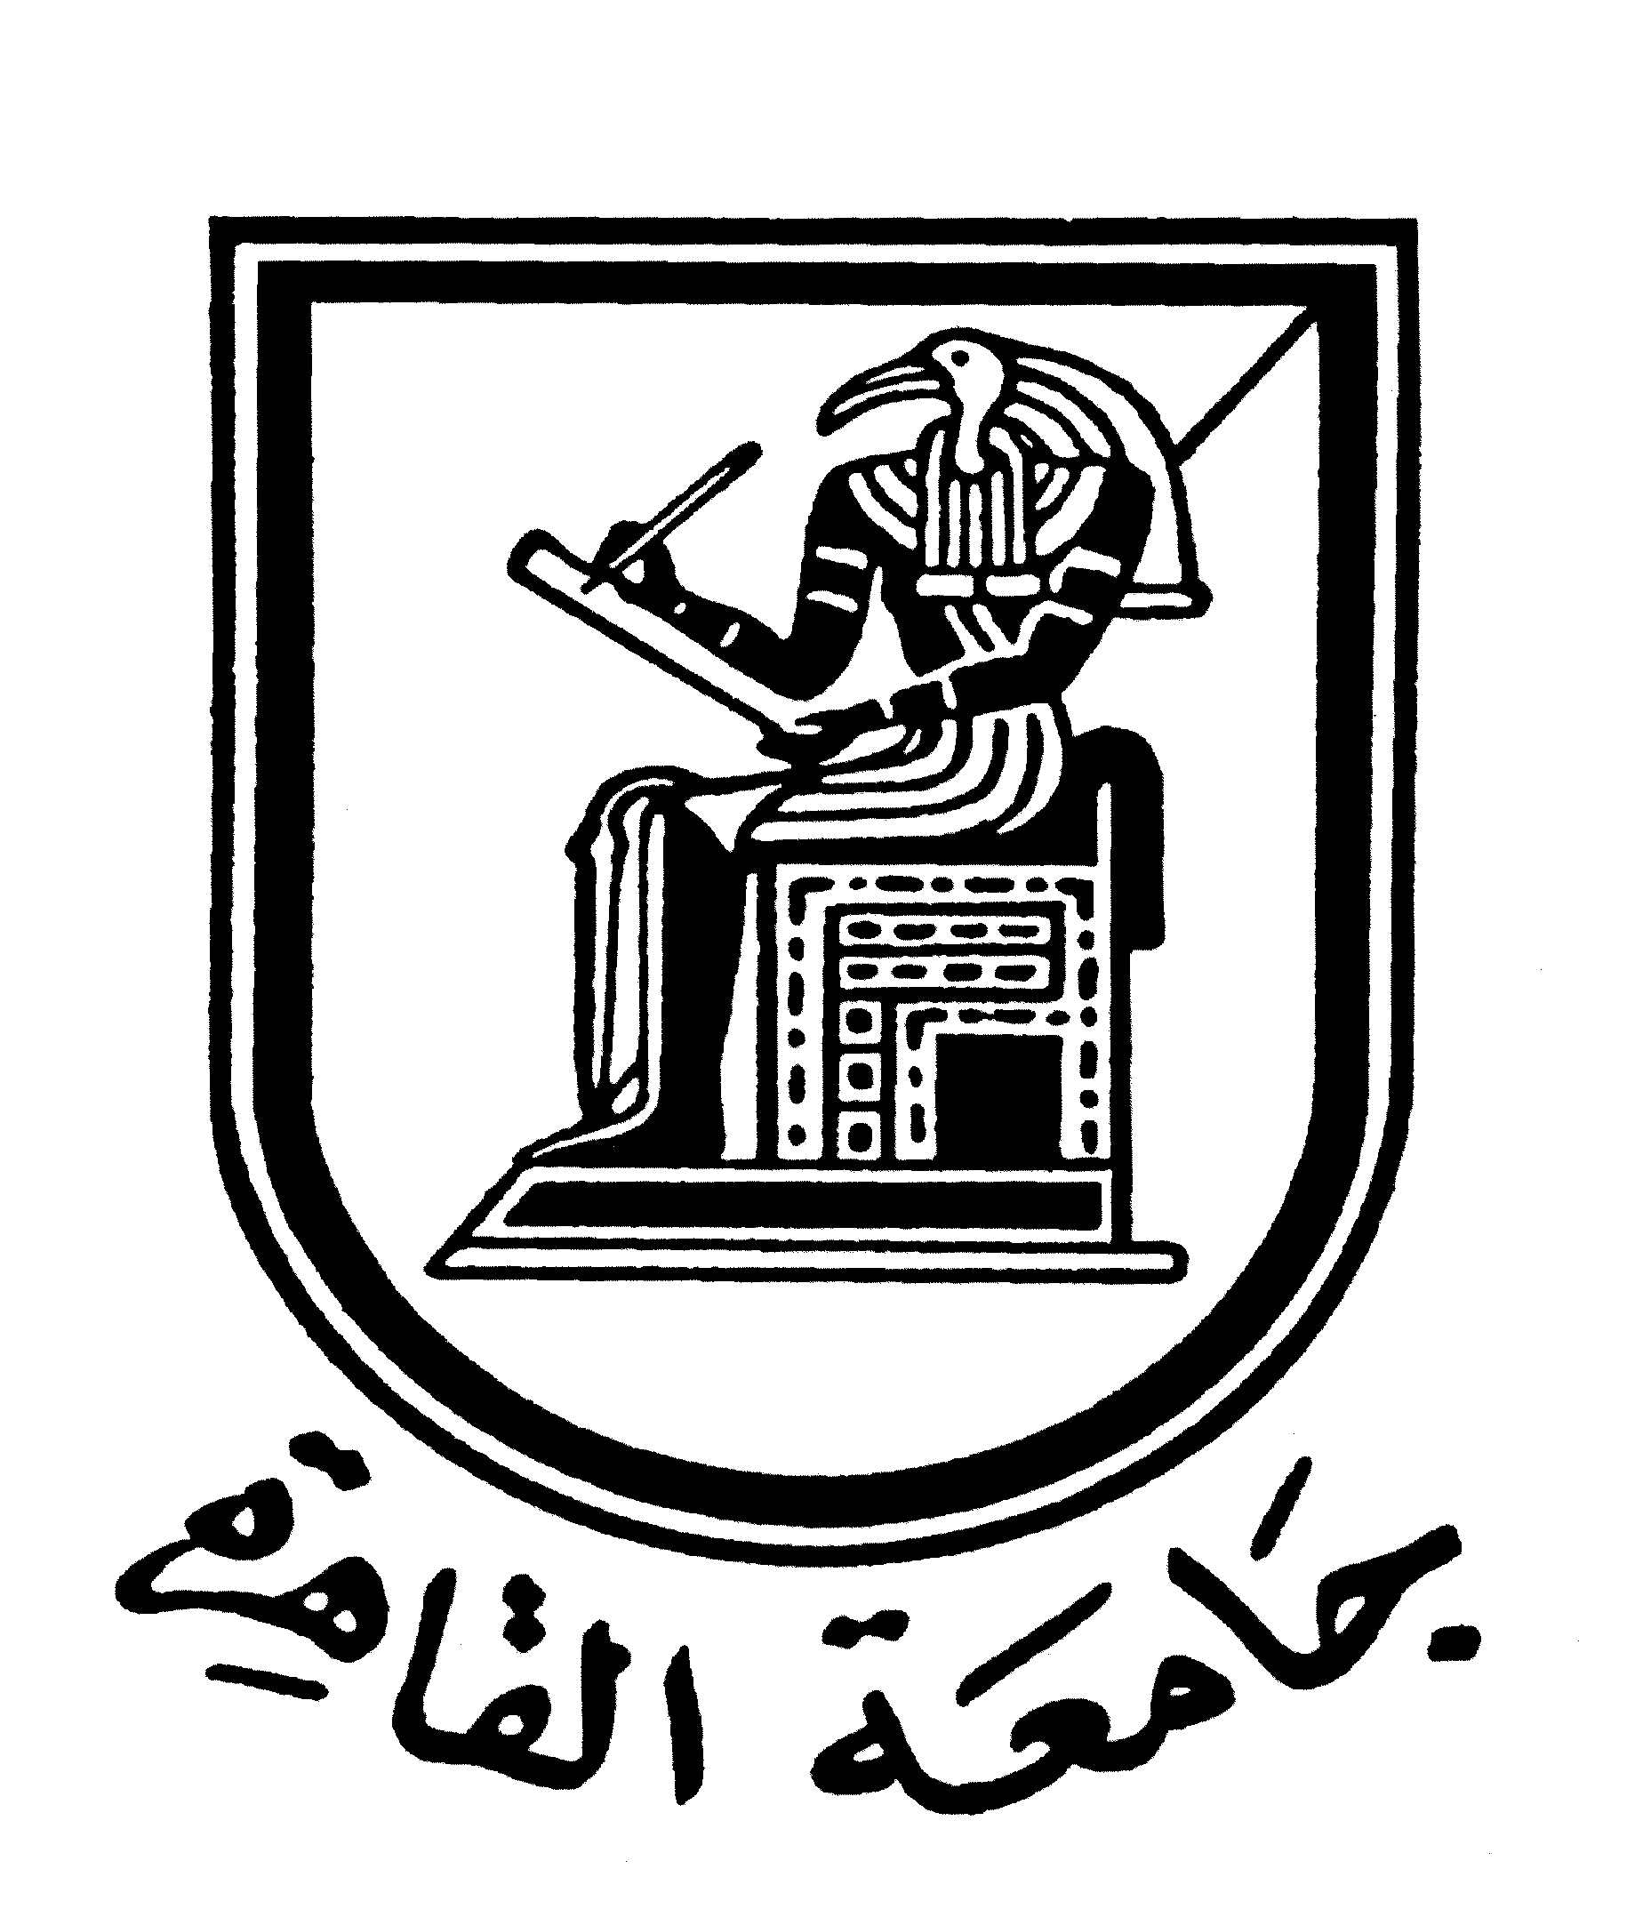 |  | 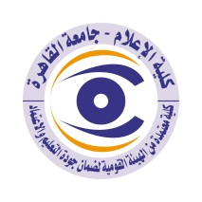

Brief CV (of the members of the academic staff)
- Name: Prof. Dr. Mohamed Mahmoud Mohamed El Morsi
- The Academic Department: Radio and Television
- Academic degree: Full Professor
- The title of the master’s thesis, the year and the entity it was obtained from:
- ( An Analytic study of the Egyptian Television News Service) Faculty of Mass Communication, Cairo University 1984.
- The title of the doctoral thesis the year and the entity it was obtained from:
- (The Image of the Economic Openness in the Egyptian Movies) Faculty of Mass Communication, Cairo University 1988.
- Courses taught in the Bachelor program:

- Introduction to Radio and Television/Radio and Television Production/Radio and Television Planning.
7. The most important reference books issued by the faculty member to benefit from his scientific research (a maximum of five books):
- A book entitled "Radio and Television News", Cairo University Centre for Open Education, 2014, in partnership with Dr. Barakat Abdulaziz
- A book entitled "The Foundations of Television Production", Faculty of Mass Communication, and Cairo University 2012
-The book "Talk Shows on Gulf Cooperation Council Televisions: An Analytical Study", Gulf Television, Riyadh, 2005
- A book entitled "The Custodian of the Two Holy Mosques: Twenty Years of Giving and Achievement", King Abdulaziz University, 2002.
- A book entitled "Introduction to the means of communication", Jeddah, Dar Zahran, 2001
8. The five most recent academic researches that have been published:
- Work paper of the scientific initiative of the Faculty of Mass Communication to support domestic tourism 2015.
- Work paper of the scientific initiative of the Faculty of Mass Communication to support Maspero, 2016.

9. The most recent five scientific theses (Master's and Ph.D.) that have been supervised:
- Rania Fawzy (PhD): The image of the security and military services as reflected in the films.
- Marwa Fouad Abdel Fattah (PhD):
News treatment of Arab political issues on The Voice of the Arabs (Sawt Al-Arab) and BBC Arabic radio stations.
- Aya Mohamed Saeed (Masters): The Egyptian youth’s perception of the university professor’s image as reflected in the television drama.
- Awaf Tariq Abdel Moneim (Master):
Ethics of professional practice for broadcasting advertisements on Egyptian satellite channels.
- Mary Khamis Bakhet (Master): Christian satellite channels address social issues in Egypt.

10. Other activities of the member of the academic staff in order to develop the educational process and serve students other than the teaching activity:
-Organizing, holding and participating in seminars, conferences and panel discussions held by the Faculty of Mass Communication, Cairo University and many other faculties in Egyptian and Arab universities.
-Contributing to the updating of curricula and educational scientific tracks at the Faculty of Mass Communication.
-Contributing to the various student activities.

11. The most important leading positions that have been held:
- The head of Radio and Television Department.
- The head of Media Training, Production and Documenting Centre.

12. The most important local and international awards obtained, the year when awarded and the entity awarded them:
- Honoured by the Friedrich Naumann Foundation for working with them as a training consultant within the framework of their agreement with the Egyptian Radio and Television Union 1997.
- Honoured by the Dallah Training Foundation in the Kingdom of Saudi Arabia for organizing media training courses in the various Gulf countries, 2004.
- Honoured by Gulf TV in the Kingdom of Saudi Arabia for organizing media training courses in various Gulf countries, 2005.
- Honoured by the Department of Media, College of Arts and Humanities, King Abdulaziz University, Kingdom of Saudi Arabia, 2007.
- Honoured by the Faculty of Mass Communication, Cairo University, 2017

Mobile: 01004050421
Email address: morsi33@hotmail.com

