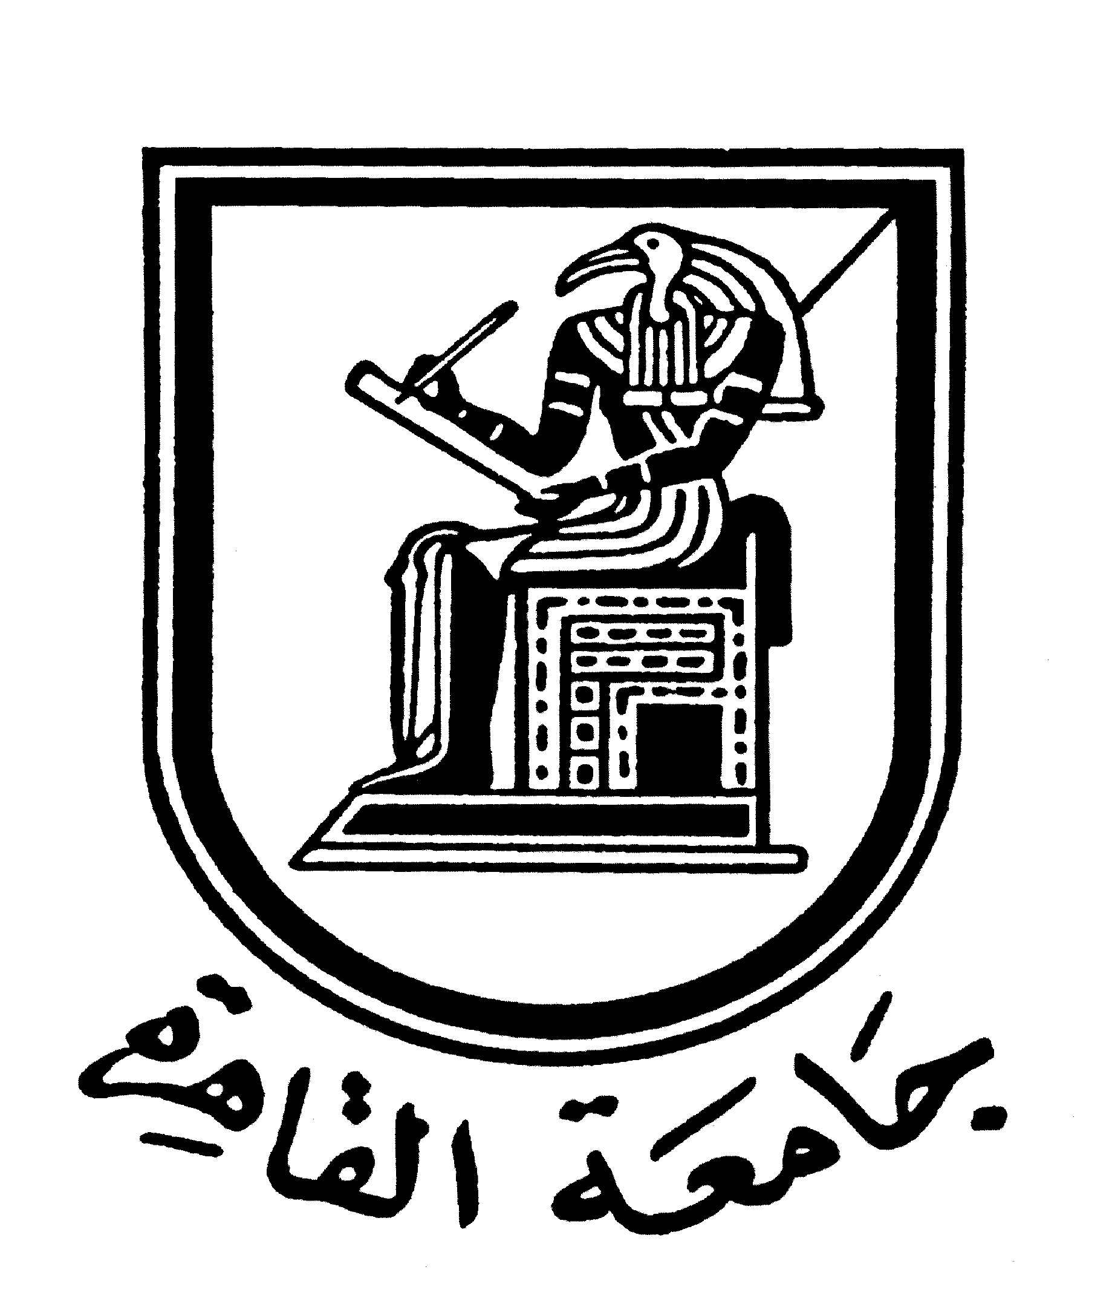 |  | 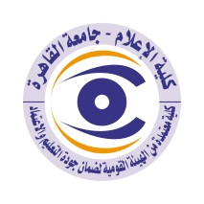

Curriculum vitae (brief) for Faculty Members
- Name: Farag Elkamel
- Scientific Department: Radio and Television
- Academic degree: “Professor, Faculty of Mass Communication, Cairo Universit
- Title of the master’s thesis, year, and the entity faculty members was obtained from:

Master of Arts (M.A) - 1978 – Communication/Social Development - University of Chicago, Chicago, IL, USA

- Title of the doctoral thesis, year, and the entity faculty members was obtained from:

Doctorate of Philosophy (Ph.D.) - 1981 – Sociology/Communication - University of Chicago, Chicago, IL, USA
- Courses taught in the Bachelor (undergraduate) Program:
  - Health, Population and Environmental Communication
  - Evaluation & Communication Research
  - Strategy Development and Strategic Planning
  - Communication for Development / Social Marketing
  - Creative Writing and Media Materials Production

- The most important reference books issued by the faculty member to benefit from his scientific research (maximum of five books).

- Principles of Communication, Fairouz Maadi, 2002.
- Dialogue with the Future, UNICEF, 2001. (Arabic and English editions)
- Public Opinion and Communication Research Methods (in Arabic), University Publishing House, 2001.
- Developing Communication Strategies and Programs: A Systematic Approach. UNICEF Regional Office for the Middle East and North Africa. Amman, Jordan. April 1986 (Arabic, English and French editions).
- Communication: A Guide for CDD Program Managers. The World Health Organization, Geneva 1986. Coauthored by William Smith, Elizabeth Booth and C. Verzosa.
- The Effects of Communication (in Arabic), 1985. Dar el Fikr.
- Communication and Family Planning in Egypt (in Arabic, with Donald J. Bogue), 1981.

8. The five most recent scientific research published for faculty member:
- “A Civil State or Troy’s Horse: What does a ‘civil state’ mean to Egyptians?” Paper presented at the International Conference on Religion and Democracy in Europe and the Arab World, Lebanese American University,
- Byblos, 29-30 November 2012
- “Media and the Egyptian revolution” Paper presented at the conference on “Cross Cultural Education” , Notre Dame University-Lebanon, 2- 3 June 2011.
- “Do Western Media Understand Islam?” Paper presented at the Workshop on “Islam and the Western World: the Role of the Media.” Università della Svizzera Italiana, Lugano, Switzerland. March 16th-17th 2007
- “Soap Operas May be Good for Health". Eastern Mediterranean Health Journal, Vol.4, No. 1, 1998. World Health Organization.
- "Can Mass Media Prevent AIDS"? Eastern Mediterranean Health Journal, Vol.2, No. 3, 1996. World Health Organization.
- "The Use of Television Series in Health Education". Health Education Research, Vol. 10, No. 1, Oxford University Press. January 1995.
- "A Global Strategy for Mass Education and Communication for AIDS Prevention". Journal of Communication, University of Cairo Press, October 1994.

- The most recent five research (Master's and Ph.D.) faculty member supervised:

- The activities faculty member carry out in the college (other than teaching) and contribute to developing the educational process and serving students

- The most important academic leadership positions that faculty member held
- (10/2013 – 10/2015) Member of the Environmental Communication Committee, Supreme Council of Culture, Egypt. Develop with the committee guidelines for effective strategies for culture and the environment (6/2013 - 9/2013) Consultant to Futures Group International
- (12/2012 – present) Member of the UNESCO scientific committee for the dialogue of civilizations.
- (7/2012-10/2012) Chief technical consultant.

- The most important local and international awards that faculty member obtained, Awarded year and entity:

CONTACTS:
Email
Mobile-

