 |  | 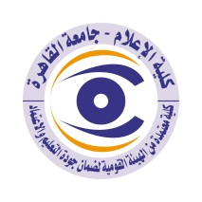

Curriculum vitae (brief) for Faculty Members
- Name: Awatef Abdul Rahman
- Scientific Department: Journalism
- Academic Degree: Professor
- Title of the master’s thesis, year, and the entity faculty members was obtained from:

- Title of the doctoral thesis, year, and the entity faculty members was obtained from:

- Courses taught in the Bachelor (undergraduate) Program:

- The most important reference books issued by the faculty member to benefit from his scientific research (maximum of five books).

- The untold speeches in Egypt 2010
- The media and women in upper Egypt 2009
- The contemporary African media 2009
- The press and universities 2008
- Media and alternative globalization 2006
- The five most recent scientific research published for faculty member:

- The most recent five research (Master's and Ph.D.) faculty member supervised:
- 14 MA and PDF theses
- Other activities of a faculty member to develop the educational process and serve students other than the teaching activity:
- Member of several international and regional associations for mass communication.
- The most important academic leadership positions that faculty member held:
- Ex vice0dean of faculty of mass communication cairo university
- The most important local and international awards that faculty member obtained, Awarded year and entity:
- The higher state award in social sciences 2014
- The higher scientific award in social sciences of Cairo university 2010
- The Arab league reward for activities and scientific works about woman 2008
- Mondela award of liberation movement 1994
- Sultan el Ewais in social and future science 1996

Contacts
Email:
Mobile:

