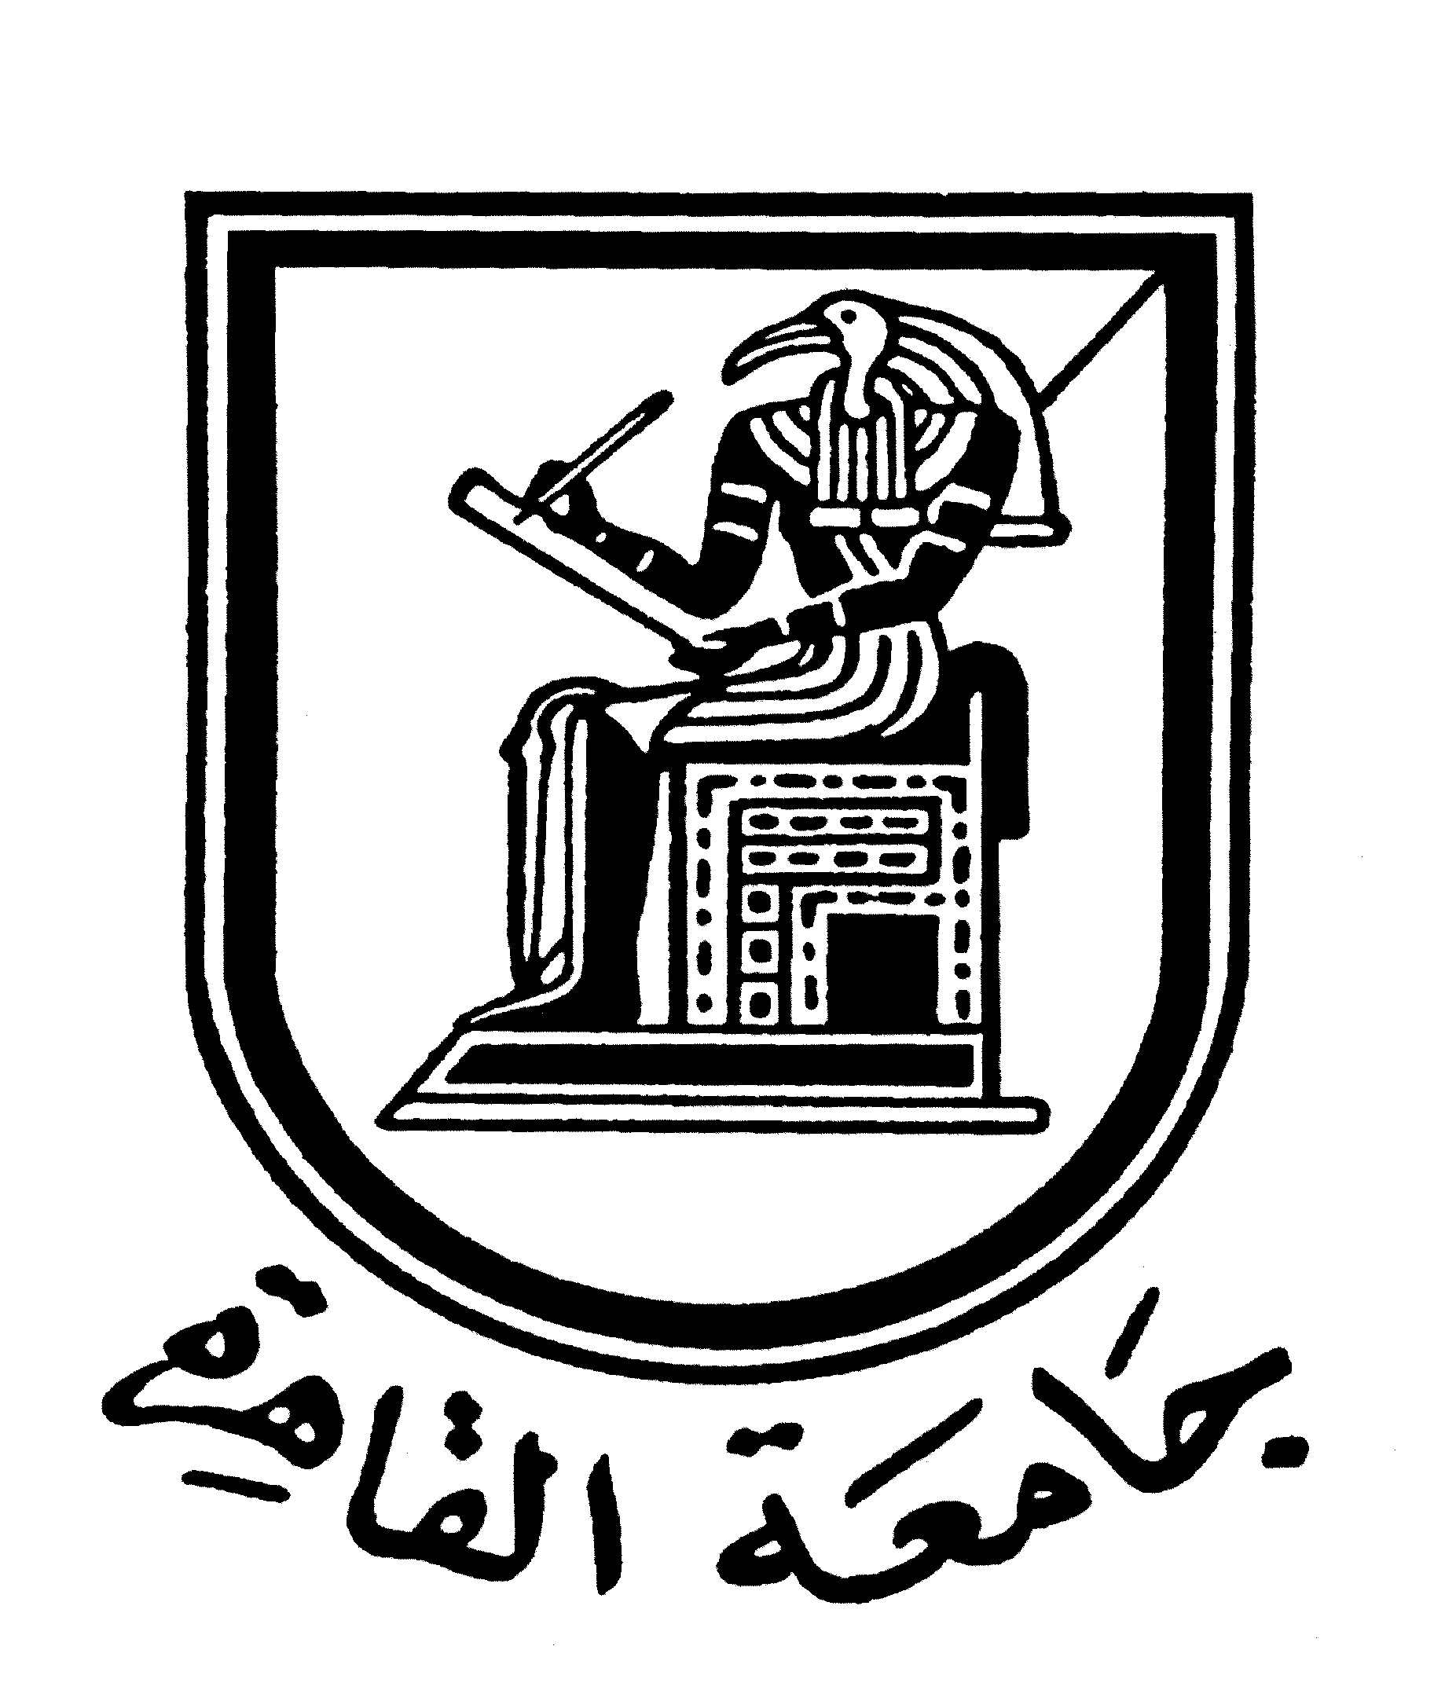 |  | 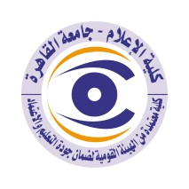

Curriculum vitae (brief) for Faculty Members (Staff)
- Name: Sherif Darwish Al-Labban
- Academic Department: Journalism
3. Academic Degree: Professor
4. The Title of the master’s thesis, year, and the entity it was obtained from:
- Obtained a master’s degree in media from the Department of Journalism, grade: excellent, for a thesis entitled: “Producing the Weekly Newspapers, An Applied Study on “Akhbar Al-Youm” newspaper from 1944 to 1988”, in 1990.
5.The Title of the doctoral thesis, year, and the entity it was obtained from:
- Obtained Ph.D. in media from the Journalism Department, "first honor" grade for a thesis entitled: "Colors in the Egyptian press and the problems of its production, an applied study from 1921 to 1990", in 1994.
6.Courses taught in the Bachelor (undergraduate) Program:
- E- press.
- Press and printing technology.
7.The most important reference books issued by the faculty member to benefit from his scientific research (a maximum of five books).
- The Internet: Legislation and Ethics, (Cairo: Dar Al-Alam Al-Arabi, 2011).
- Interventions in alternative media and e-publishing, (Cairo: Dar Al-Alam Al-Arabi, 2011).
- Communication Arts and Specialized Media, (Cairo: Al Dar Al Masriah Al Lubnaniah, 2009), in partnership with Prof. Mona Elhadidy.
- Communication technology and society: issues and problems, (Cairo: Dar Al-Alam Al-Arabi, 2009).
- Introduction to Media Research Methods, (Cairo: Dar Al Arabia for Publishing and Distribution, Dar Al Arabia Series for Open Education, Media Studies, 2008), in partnership with Dr. Hisham Attia.

8. The five most recent scientific research published for faculty member:
- The editorial policy of media institutions with multiple platforms: a field study on those in charge of communication, Scientific Journal of Press Research, No. 19, January / June 2020.
In partnership with researcher Ali Jamal Ali Khalifa
- Immunizing Arab youth against media penetration: risks, problems, and confrontation mechanisms, Araa on the Gulf Journal, Issue 147, March 2020.
- The semiology of the press image in Western communication channels directed through social networks and its role in shaping the attitudes of the Western public towards the issue of terrorism by applying to the incident of the terrorist attack on Al-Rawda Mosque in Sinai, Scientific Journal for Press Research, Issue. 19, January / June 2020.
In partnership with Sally Muhammad Ali Barakat
- Braille Readers’ Attitudes towards the Design of Printed Magazines for them, Scientific Journal of Press Research, Issue 19, January/June 2020.
- In partnership with Ibrahim Helmy Emara
Islamophobia: Why is the West afraid of Muslims? Al-Azhar University: Faculty of Mass Communication, Media Research Journal, Issue. 49, January 2018.
9. The five most recent research (Master's and Ph.D.) that faculty member supervised:
- Amani Hamdi Qarni Mahmoud: Frameworks for presenting the tourism crisis in the websites of e- newspapers and its relationship to the public’s attitudes towards it, Ph.D. thesis, unpublished, (Cairo University: Faculty of Mass Communication, 2021).
- Haitham Fathi Al-Sheikh: The use of diplomatic bodies for the new media and its reflection on the journalistic treatment of the phenomenon of terrorism: a study on foreign affairs journalists in Egyptian e-newspapers, Ph.D. thesis, unpublished, (Alexandria University: Faculty of Arts, Department of Sociology, Media, and Communication Division, 2021).
Wissam Kamal Mahmoud al-Hanbali: Media uses of portable media in Egypt: a study of the medium, the communicator and the public, Ph.D. thesis, unpublished, (Cairo University: Faculty of Mass Communication, 2021).
- Fatima Ali Hassan Al-Abasiri: Frameworks for the Egyptian newspapers' websites to address the presidential discourse towards national security issues and their relationship to shaping the public's attitudes towards them, PhD thesis, unpublished, (Cairo University: Faculty of Mass Communication, 2022).
- Fahah Hassan Al - Rabbi (Iraqi): Iraqi Public Trends Towards Credibility of the Content of Political Activists' Social Media Pages, PhD thesis, Unpublished (Cairo University: Faculty of Mass Communication, 2022).

10. The activities faculty member carry out in the college (other than teaching) and contribute to developing the educational process and serving students.
- Participation in preparing the new regulation for the bachelor's degree.
- Participation as an external reviewer for a number of study programs in the field of media inside and outside Egypt.
- Participation in the development of training programs and plans for students of the press department at the College.
11. The most important academic leadership positions that faculty member held:
- Head of the press department at the faculty from (2020-).
- Vice Dean for Community Service and Environmental Development (2014-2019).
Vice Chairman of the Board of Directors of the faculty of Mass Communication Agency for the design and implementation of media and marketing campaigns from (February 2018-August 2019).
- Secretary of the Permanent Scientific Committee formed by the Supreme Council of Universities to promote professors and assistant professors or to obtain their scientific titles in the field of media in the eleventh session (2013-2015).
- Head of the Media Studies Unit at the Arab Center for Research and Studies from (2013-2021).
- Director of Cairo University Center for Printing and Publishing from (2008-2011).
- Director of the Public Opinion Research and Studies Center at Cairo University from (2007-2008).
Head of the Journalism Department at the Faculty of Media and Communication Arts at October 6 University from (January 2004 to August 2005).
- Former editor-in-chief of the "Egyptian Journal of Public Opinion Research", a refereed scientific journal issued by the "Center for Public Opinion Research and Studies" at the college.
- The current editor-in-chief of the "Scientific Journal of Press Research", a refereed scientific journal issued by the faculty`s journalism department.
- Adviser to the Academic Accreditation Commission at the Ministry of Education and Scientific Research in the United Arab Emirates since (2008-).
12. The most important local and international awards that faculty member obtained, Awarded year and entity:
- The State Incentive Award in Social Sciences in the field of "Publishing" for the year 2000 for research: "Desktop publishing and its applications in the press: a field study on Egyptian press institutions", which is considered pioneering research in this field.
- Cairo University Incentive Award for Scientific Research for the year 1996/1997 in the field of “Media Communication Technology” for the book “Printing and E- Publishing Technology” and a set of research specialized in communication technology, which were previously mentioned within the published scientific research, which was conducted between 1995, 1997.
- The Best Research Award from the Center for Women and Children Studies in Bahrain, for the research "Women and Media in Rural and Urban", which was previously mentioned within the collective research in which the researcher participated.
- Certificate of Appreciation and University Shield from Cairo University in its celebration of Science Day 2001 on the occasion of obtaining the State Incentive Award in Social Sciences for 2000.
- A shield and certificate of appreciation for the participation and success of a workshop entitled: "ISIS: The World Confronting International Terrorism" within the activities of the "Iraqi-Egyptian Media Forum" that was held in Cairo on Sunday, November 23, 2014.
- Won the Incentive Award for Endowment of Counsellor Muhammad Shawqi Al-Fangari in the field of “Ethics of Dealing with Social Media,” with research titled: “Young People’s Dealing with Social Media: A Study of Problems, Risks and Ethics” in April 2019.
- The award for the best doctoral thesis from Kafr El-Sheikh University for 2020 is shared equally with my student Samira Mohamed Mabrouk Moussa, assistant professor in the Department of Media at the Faculty of Arts, Kafr El-Sheikh University, which I supervised in her doctoral thesis entitled: The discourse of the Egyptian and Arab press towards the performance of the Egyptian economy in the period from June 2014 to June 2017 ,Analytical study on a sample of economic newspapers, PhD thesis, unpublished, (Cairo University: Faculty of Mass Communication, 2020).
- Obtaining the eighth rank (repeatedly) in the “Arcef Report 2021” in the field of media out of the total number of authors (1400) cited for their articles in this field, among more than (196000) Arab authors whose reference citations in various disciplines were studied and reviewed, out of a Total Arcef reports covering the period 2012-2019.
- "The University's Voice" newspaper won the award for the best printed student newspaper at the level of Egyptian media faculties and departments from the "Digital Media Foundation" for 2020/2021.
- The University's Voice newspaper won the award for the best printed student newspaper in the field of continuous production at the level of Arab and African media colleges and departments from the Digital Media Foundation for 2020/2021.
- Journalism Department of the Faculty of Mass Communication, Cairo University, won first place in the competition “Arab Media Youth Forum held at the Faculty of Mass Communication, Cairo University from December 12-14, 2021” in the category “Tourism Development Press” with a file on “Sunset Desert”, published in the August 2020 issue, From the "University Magazine", and the (Al-Balad) blog issued as a graduation project for the Class of 2020 students from the Journalism Department.

Mobile: 01114683040
Email: sherifalabban59@gmail.com

