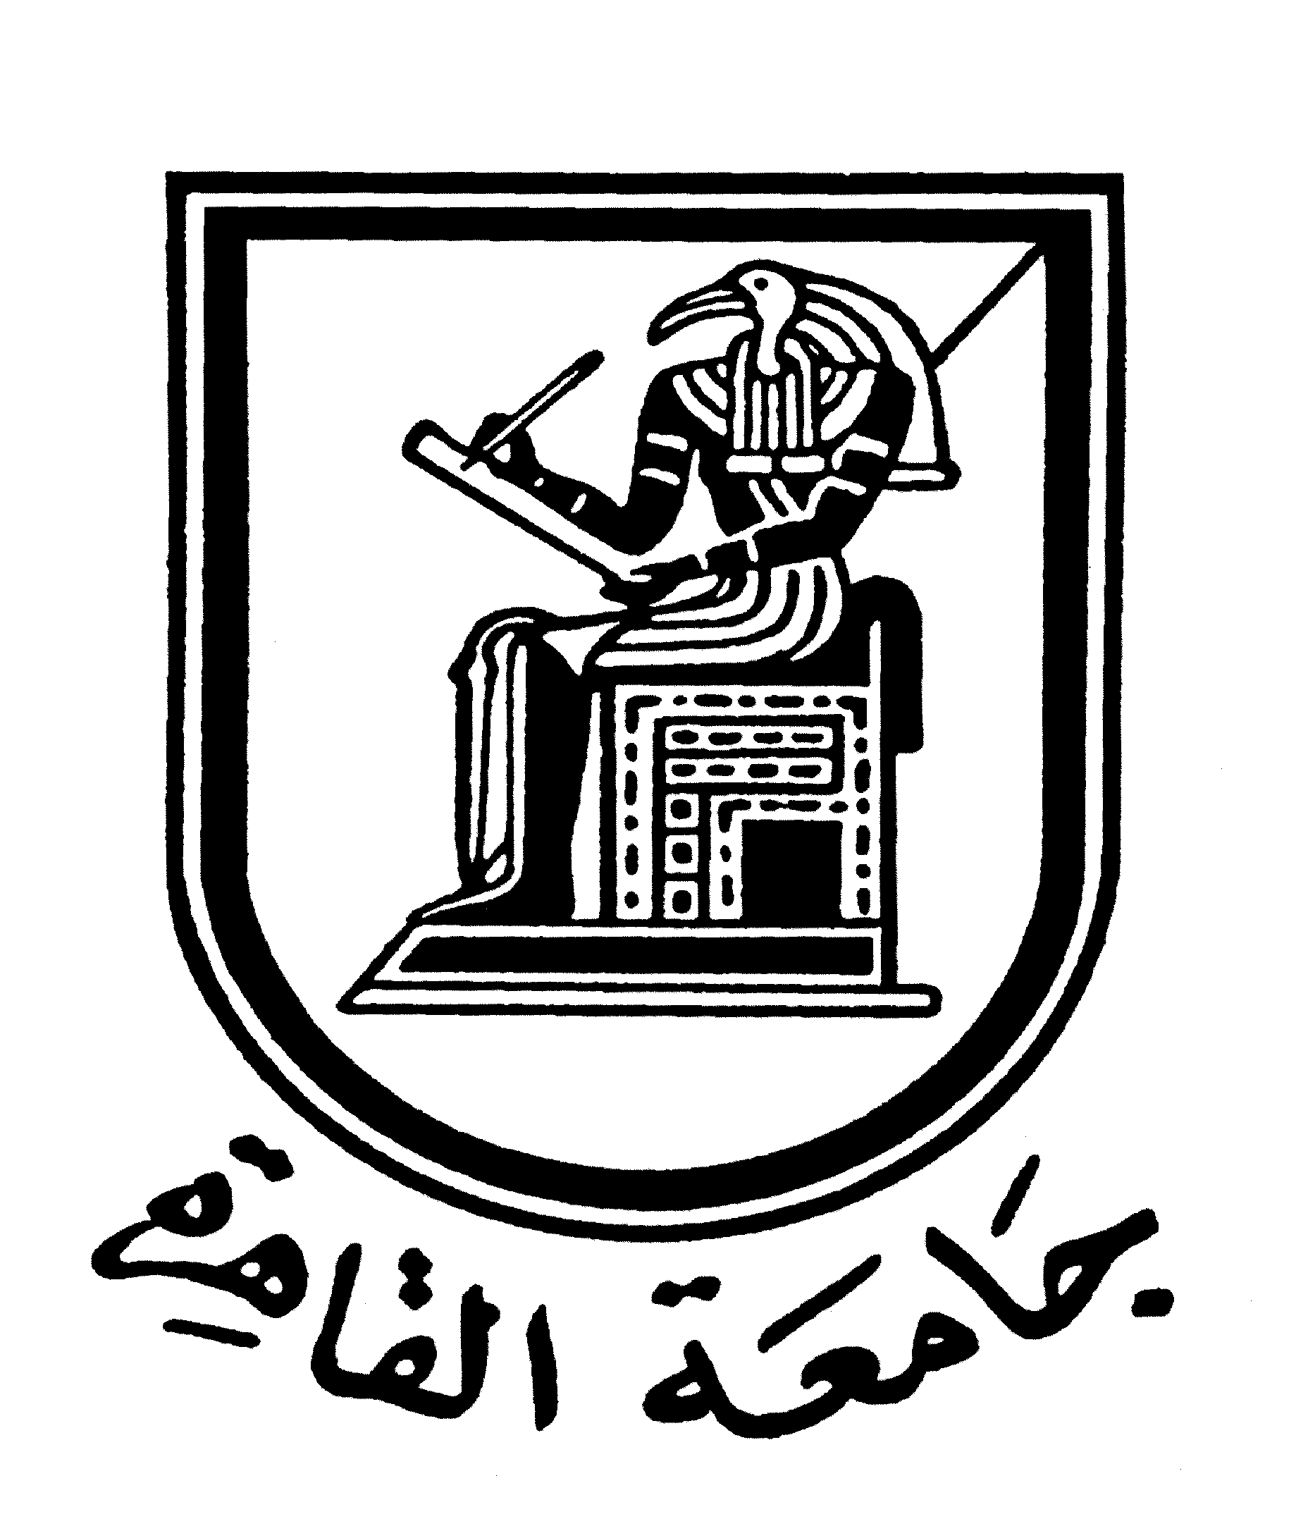 |  | 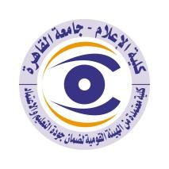

Brief CV of the members of the academic staff
1- Name: Professor .DR. Ali Al-Sayeed Ibrahim Ajwa
2- Academic department: Public relations and Advertising
3-Academic degree: Professor of Public relations and Advertising in the Faculty of Mass Communication, Cairo University.)
Teaching Assistant at PR & Advertising department, Faculty of Mass Communication
4-The title of the master’s thesis, the year and the entity it was obtained from:

5- The title of the doctoral thesis the year and the entity it was obtained from:
.
6- Courses taught in the Bachelor program:
.
The most important reference books issued to you benefiting from your academic research (no more than five books):
- Seven scientific publications in public relations from 1977 to 2008.
8- The five most recent academic researches that have been published:
-Twenty scientific research from 1974 to 2008.
9- The five most recent researches (Masters and Ph.D.) that I supervised:
Supervised forty PhD theses and fifty-five master's theses.

The activities carried out in the faculty (other than teaching) and contribute to developing the educational process and serving students:
- Internal audit course for accreditation and quality at Cairo University in 2009.
- Institutional self-evaluation course for higher education institutions at the National Authority for Quality Assurance of Education and Accreditation 2010.
- External review course for higher education institutions at the National Authority for Quality Assurance of Education and Accreditation 2010
- Head of the Media Studies Sector Committee at the Supreme Council of Universities, starting 27/7/2011.

11- The most important leading positions that have been held:
- Vice Dean of the Faculty of Mass Communication for Education and Student Affairs from 6/28/1983 to October 1986, and from 2/10/1994 to 9 September 2000.
- The Head of Public relations and Advertising Department 07/09/1985.
- The Dean of the Faculty of Mass Communication starting from 10 of September 2000 until 9 September 2003.
- Deputy Supreme Council for the Press 2002-2006.
- Member of the Board of Trustees of the Radio and Television Union, 2002-2004.
- Head of the News, Political Programs and Current Events Committee at the Radio and Television Union, 2002-2004.
- Media Adviser to the Ministry of Water Resources and Irrigation, 1994 until July 2005.

12- The most important local and international awards obtained, the year when awarded and the entity awarded them:
-Received the Cairo University Appreciation Award in Social Sciences in 2008.
-Received the shield of Cairo University, the universities of Damascus, King Abdulaziz, the United Arab Emirates, Bahrain, Mutah in Jordan, Tanta, Menoufia, October 6, the National Centre for Social and Criminal Research, the Cultural Development Fund at the Ministry of Foreign Affairs, the Arab Cultural Forum, the Department of Press and Media at Al-Azhar University.

Contact means:
E-mail :
Mobile:

