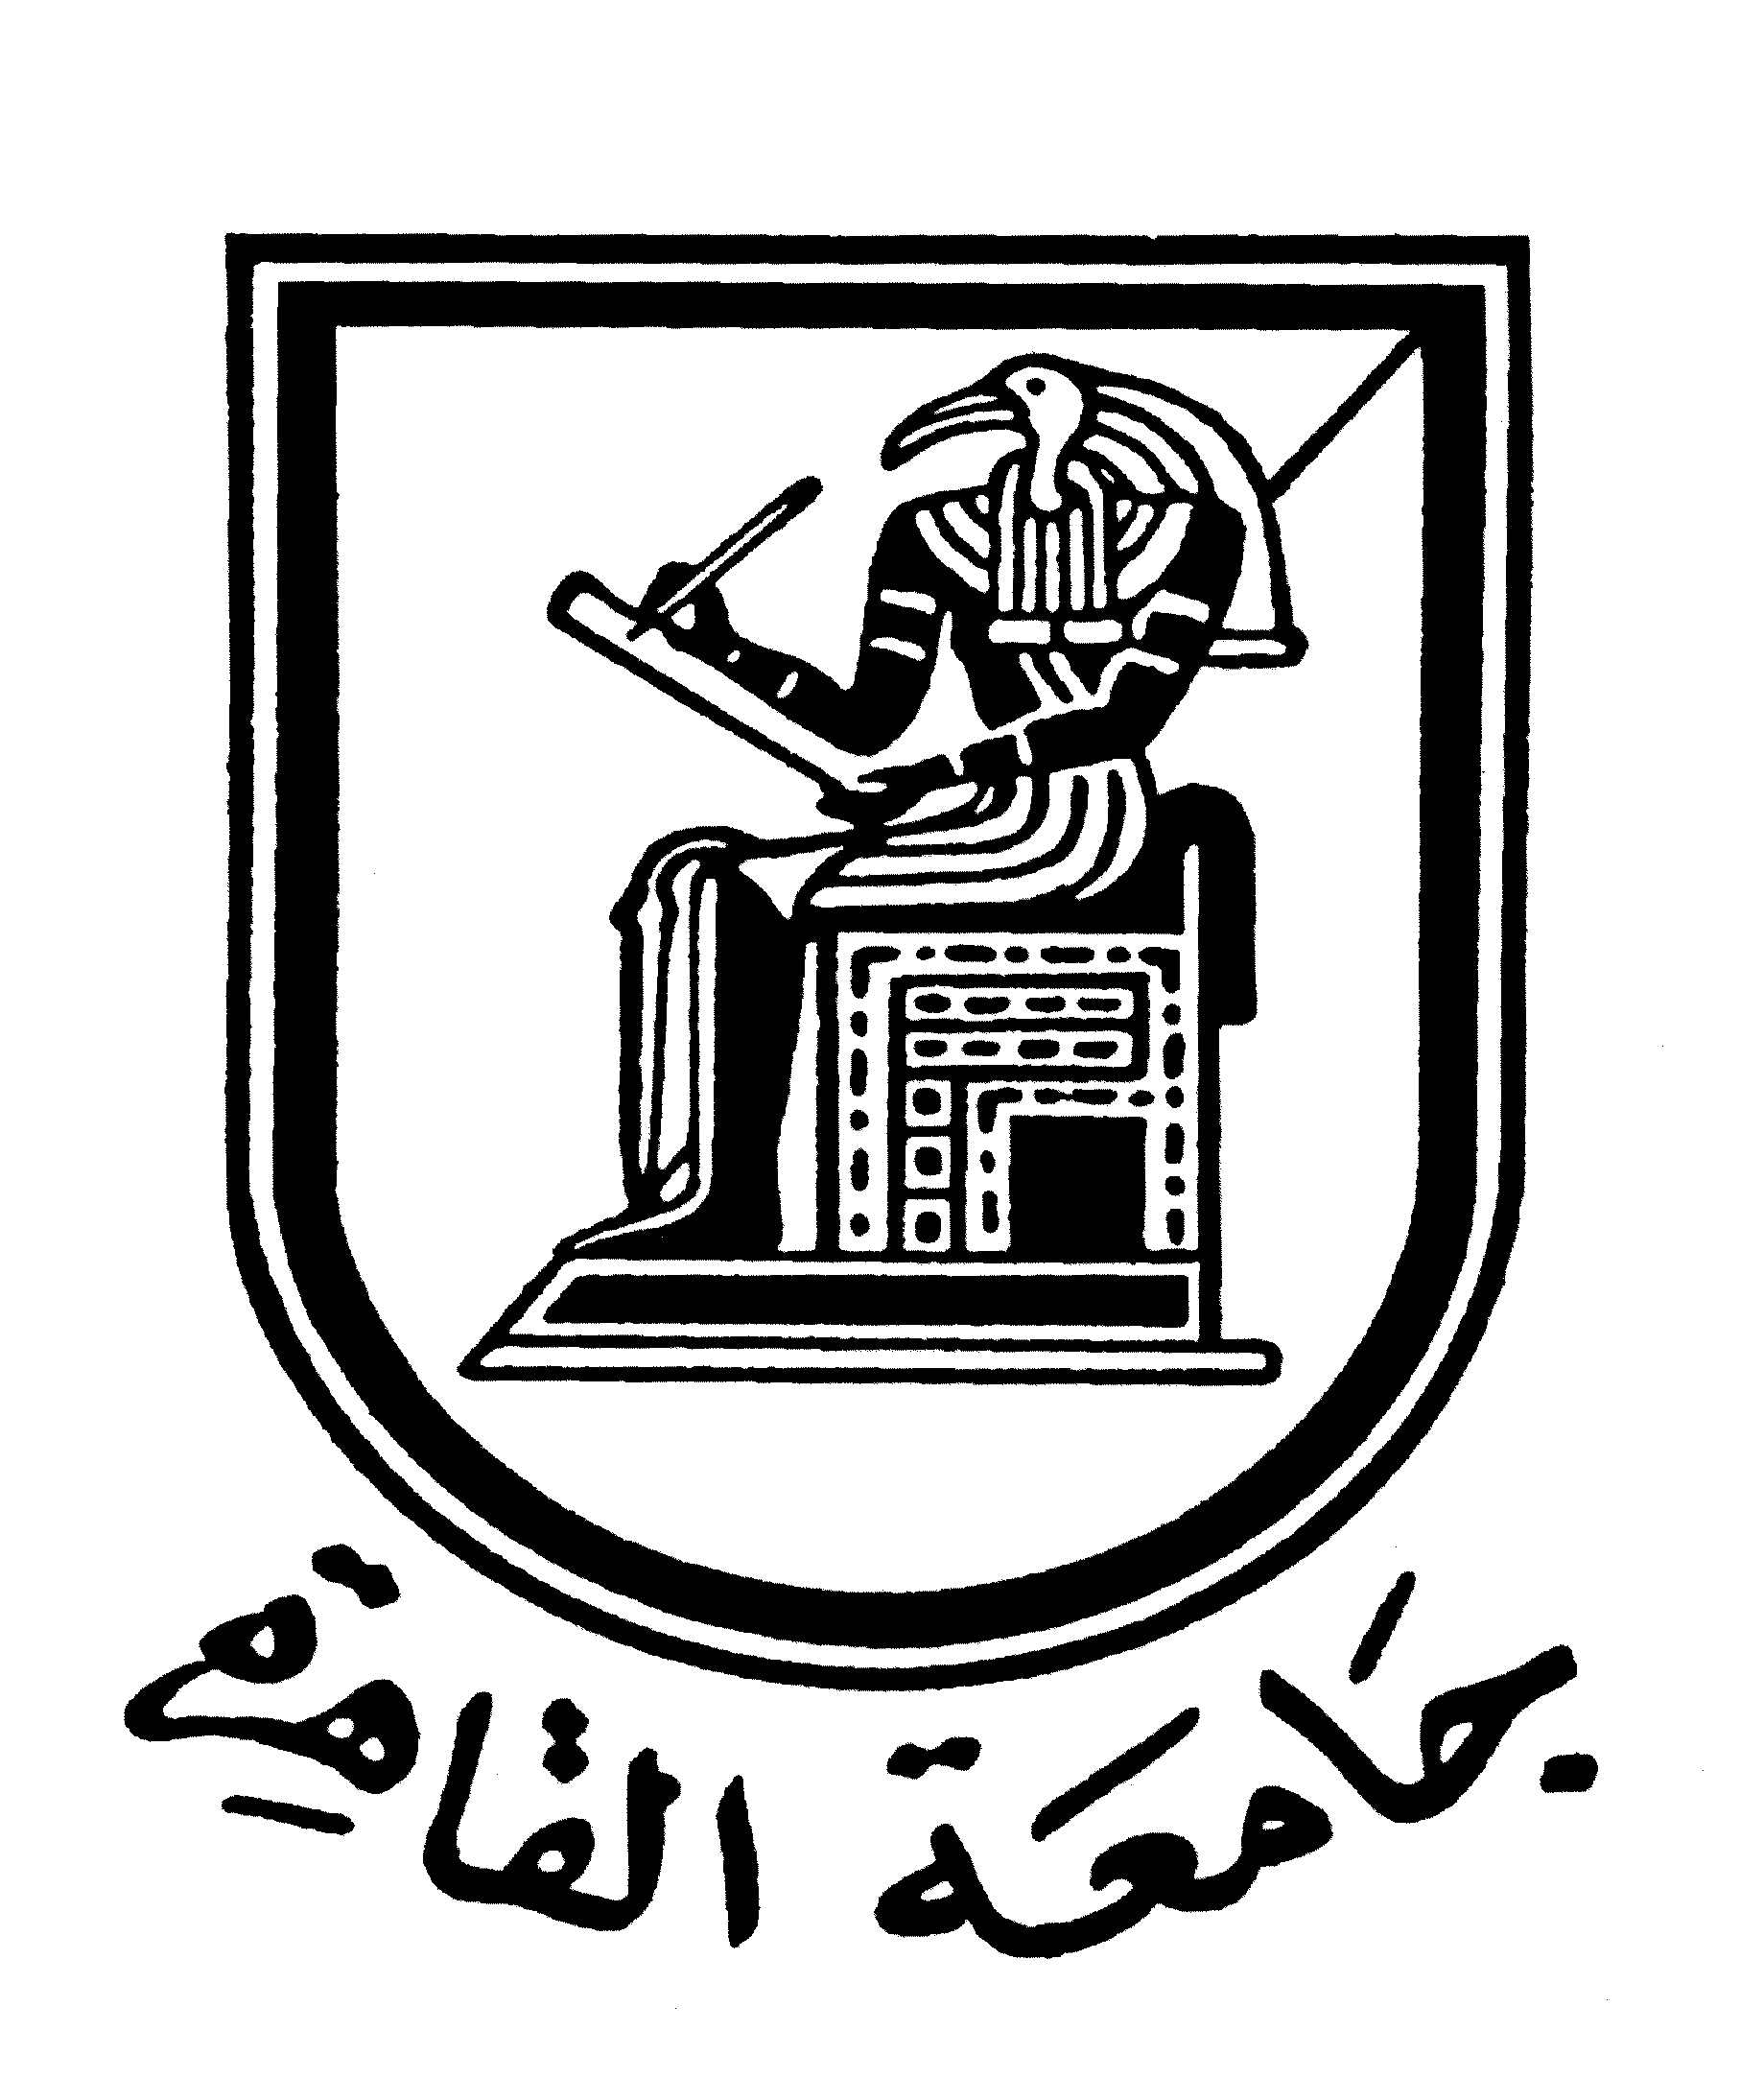 |  | 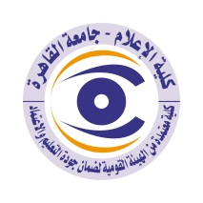

Curriculum vitae (brief) for Faculty Members (Staff)
- Name: Ragia Ahmed Kandil
- Academic Department: Journalism
3. Academic Degree: Professor
4. The Title of the master’s thesis, year, and the entity it was obtained from:

5.The Title of the doctoral thesis, year, and the entity it was obtained from:
6.Courses taught in the Bachelor (undergraduate) Program:
Public opinion - International Press - Propaganda and Convincing - Media Translation
7.The most important reference books issued by the faculty member to benefit from his scientific research (a maximum of five books).
8. The five most recent scientific research published for faculty member:
9. The five most recent research (Master's and Ph.D.) that faculty member supervised:
10. The activities faculty member carry out in the college (other than teaching) and contribute to developing the educational process and serving students.
Participation in the implementation of training courses for media professionals and practitioners in the areas of political education for youth and women, public opinion polls and measurements, public research and measuring the efficiency of government performance.
11. The most important academic leadership positions that faculty member held:
12. The most important local and international awards that faculty member obtained, Awarded year and entity:

Contact means:
E-mail :
Mobile:

