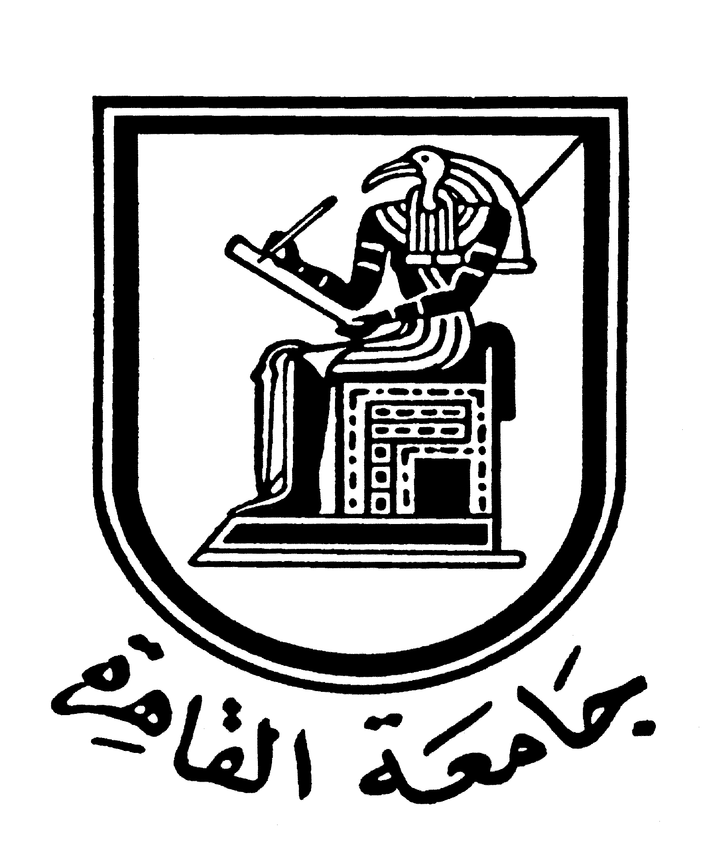 |  | 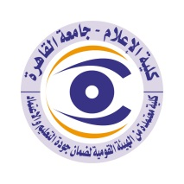

Brief CV (of the members of the academic staff)
1- Name: Nermin Abdulsalam Mohammed Hassan
2-Academic department: Journalism.
3-Academic degree: Teacher.
4-The title of the master’s thesis, the year and the entity it was obtained from:
(The Evolution of Egyptian Society Issues in Ahmed Bahaa El-Din’s Articles - A Comparative Analytical Study), Department of Journalism, Faculty of Mass Communication, Cairo University, 2003.

5- The title of the doctoral thesis, the year and the entity it was obtained from:
(The relationship between news format editing templates and readers’ understanding and remembering the content, an analytical and empirical comparative study between print newspapers and the Internet), in 2016, Journalism Department, Faculty of Mass Communication, Cairo University.

6- Courses taught in the Bachelor program:
Scientific Media.

7- The most important reference books issued by the faculty member to benefit from his scientific research (a maximum of five books):
None.
8- The five most recent academic researches that have been published:
None.
9- The most recent five scientific theses (Master's and Ph.D.) that have been supervised:
None.

10- Other activities of the member of the academic staff in order to develop the educational process and serve students other than the teaching activity:
None.

11- The most important leading positions that have been held:
None.
12- The most important local and international awards obtained, the year when awarded and the entity awarded them:
None.
Mobile: 01009722206
Email:
nermeen_abdelsalam @hotmail.com

