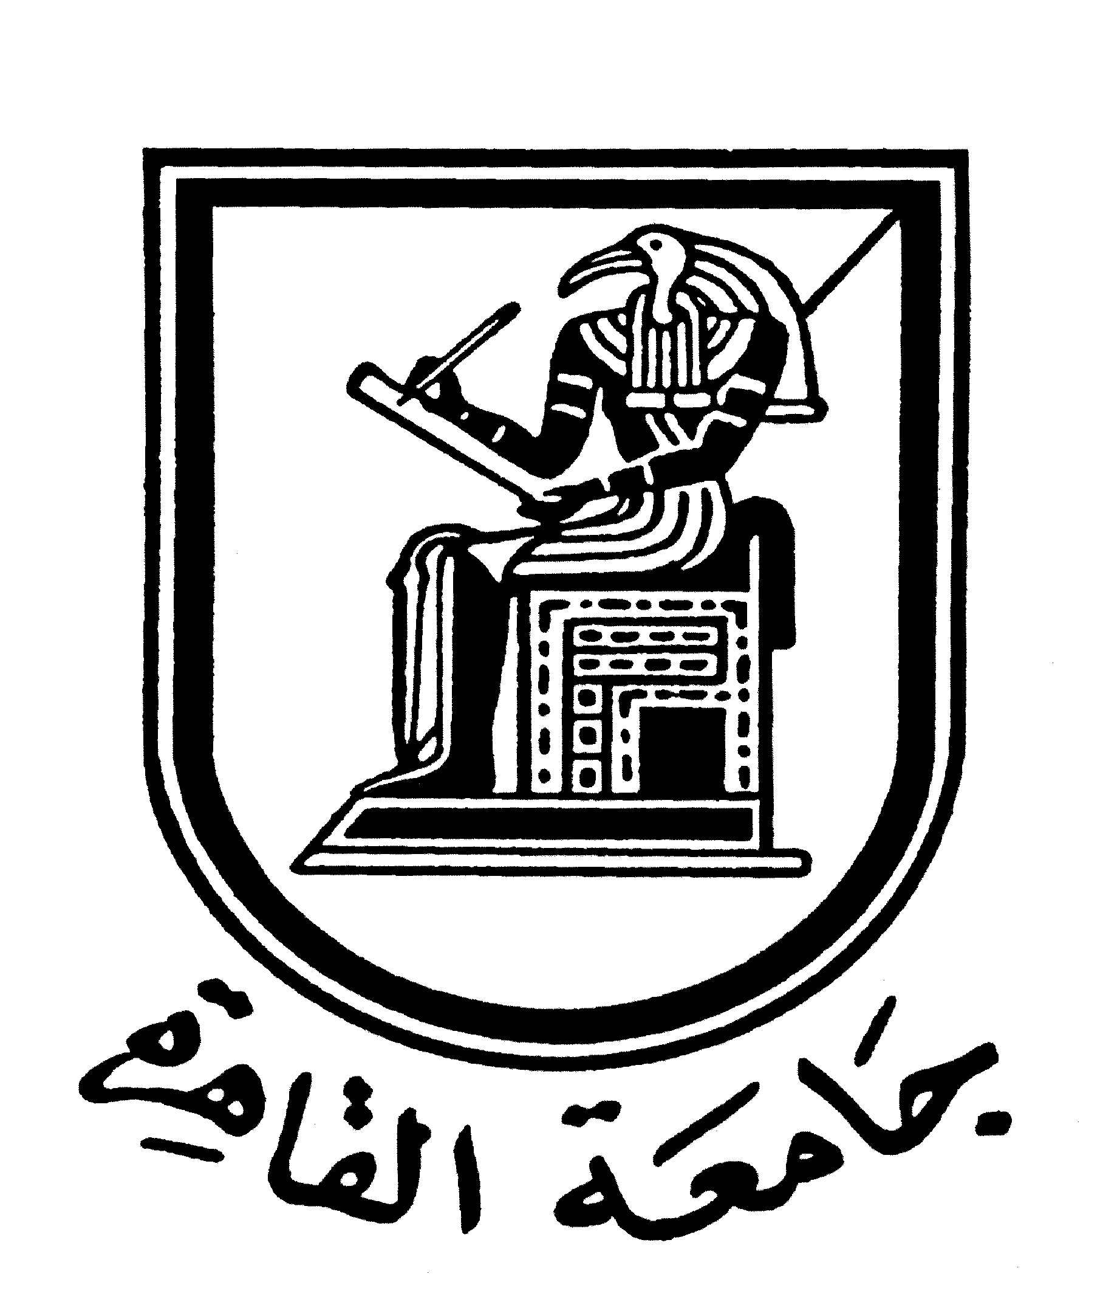 |  | 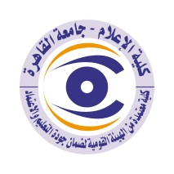

Brief CV of the members of the academic staff
Name: Nermeen Al-Azrak
Academic department: Journalism
Academic degree: Assistant Professor
The title of the master’s thesis, the year and the entity it was obtained from:
M.S.c “Master Degree of Mass Communication”, Department of Journalism, Faculty
Mass Communication, Cairo University. November 2002.
Title of Thesis: "The laws of newspapers ownership in Egypt". Excellent degree with
Honour.
The title of the doctoral thesis the year and the entity it was obtained from:
M.S.c “Master Degree of Mass Communication" Department of Journalism, Faculty
Mass Communication, Cairo University. November 27, 2008. Title of Thesis: “Press freedom
in Egypt: Study of the relationship between governmental policies and practicing of the
Egyptian newspapers in the period from 1995-2005”. Excellent degree with honour.
Courses taught in the Bachelor program:
Mass Communication Theories- Mass Communication Laws and Ethics.
The most important reference books issued to you benefiting from your academic research (no more than five books)
N. Al-Azrak “Press freedom in Egypt: Study of the relationship between governmental
Policies and practicing of the Egyptian newspapers in the period from 1995-2005” Ed. ElAlam El-Arabi, 2009
The five most recent academic researches that have been published:
1- Judgment and Mass communication in Cairo University (April 7&8, 2010, Cairo,
Egypt).
2- Mass communication and Arabic language in Cairo University (March, 2010, Cairo,
Egypt).
3- The relationship between mass communication and the Arabic family in Cairo
University (March, 2009, Cairo, Egypt).
2- Mass communication and Arabic language in Cairo University (March, 2009, Cairo,
Cairo, Egypt).
5- The Universal and public mass communication in Cairo University (May, 1997, Cairo,
Egypt).
The five most recent researches (Masters and Ph.D.) that I supervised:
The future of Mass communication in Egypt through upcoming ten years “Shimaa
Mohamed” Master thesis, Department of Journalism, Faculty of Mass
Communication, Cairo University, 2009 till now.
The factors affecting the international and Arabic news agencies “Mai Mostafa” PhD
thesis, Akhbar El-Yom Academy, 2009 till now.

The activities carried out in the faculty (other than teaching) and contribute to developing the educational process and serving students:
Organization and preparation of the ways of scientific research’s workshop for administrative staff in the public organization of information, April 18 - 21, 2010.
Participation in the Quality Assurance Unit in Faculty of Mass Communication, Cairo
University, 2008-current.
Role:
1- Participate in the preparation and attendance of workshops and lectures.
2- Contribute in the organization of seminars hosted by the Quality Assurance Unit
of the faculty.
3- Participate in the coursed’ specification, preparing and writing the reports for the
Courses of the department of Journalism.
Participation in the shared researches of the Journalism department.

Organization and supervision of the specialized diploma of mass communication laws
and ethics, Cairo University, 2009 -current

The most important leading positions that have been held:
The head of Media Division in English Language since 2021 until now.
The most important local and international awards obtained, the year when awarded and the entity awarded them:
2- Mass communication and Arabic language in Cairo University (March, 2010, Cairo,
» Organization and supervision of the specialized diploma of mass communication laws
and ethics, Cairo University, 2009.
Contact means:
E-mail :
Mobile:

