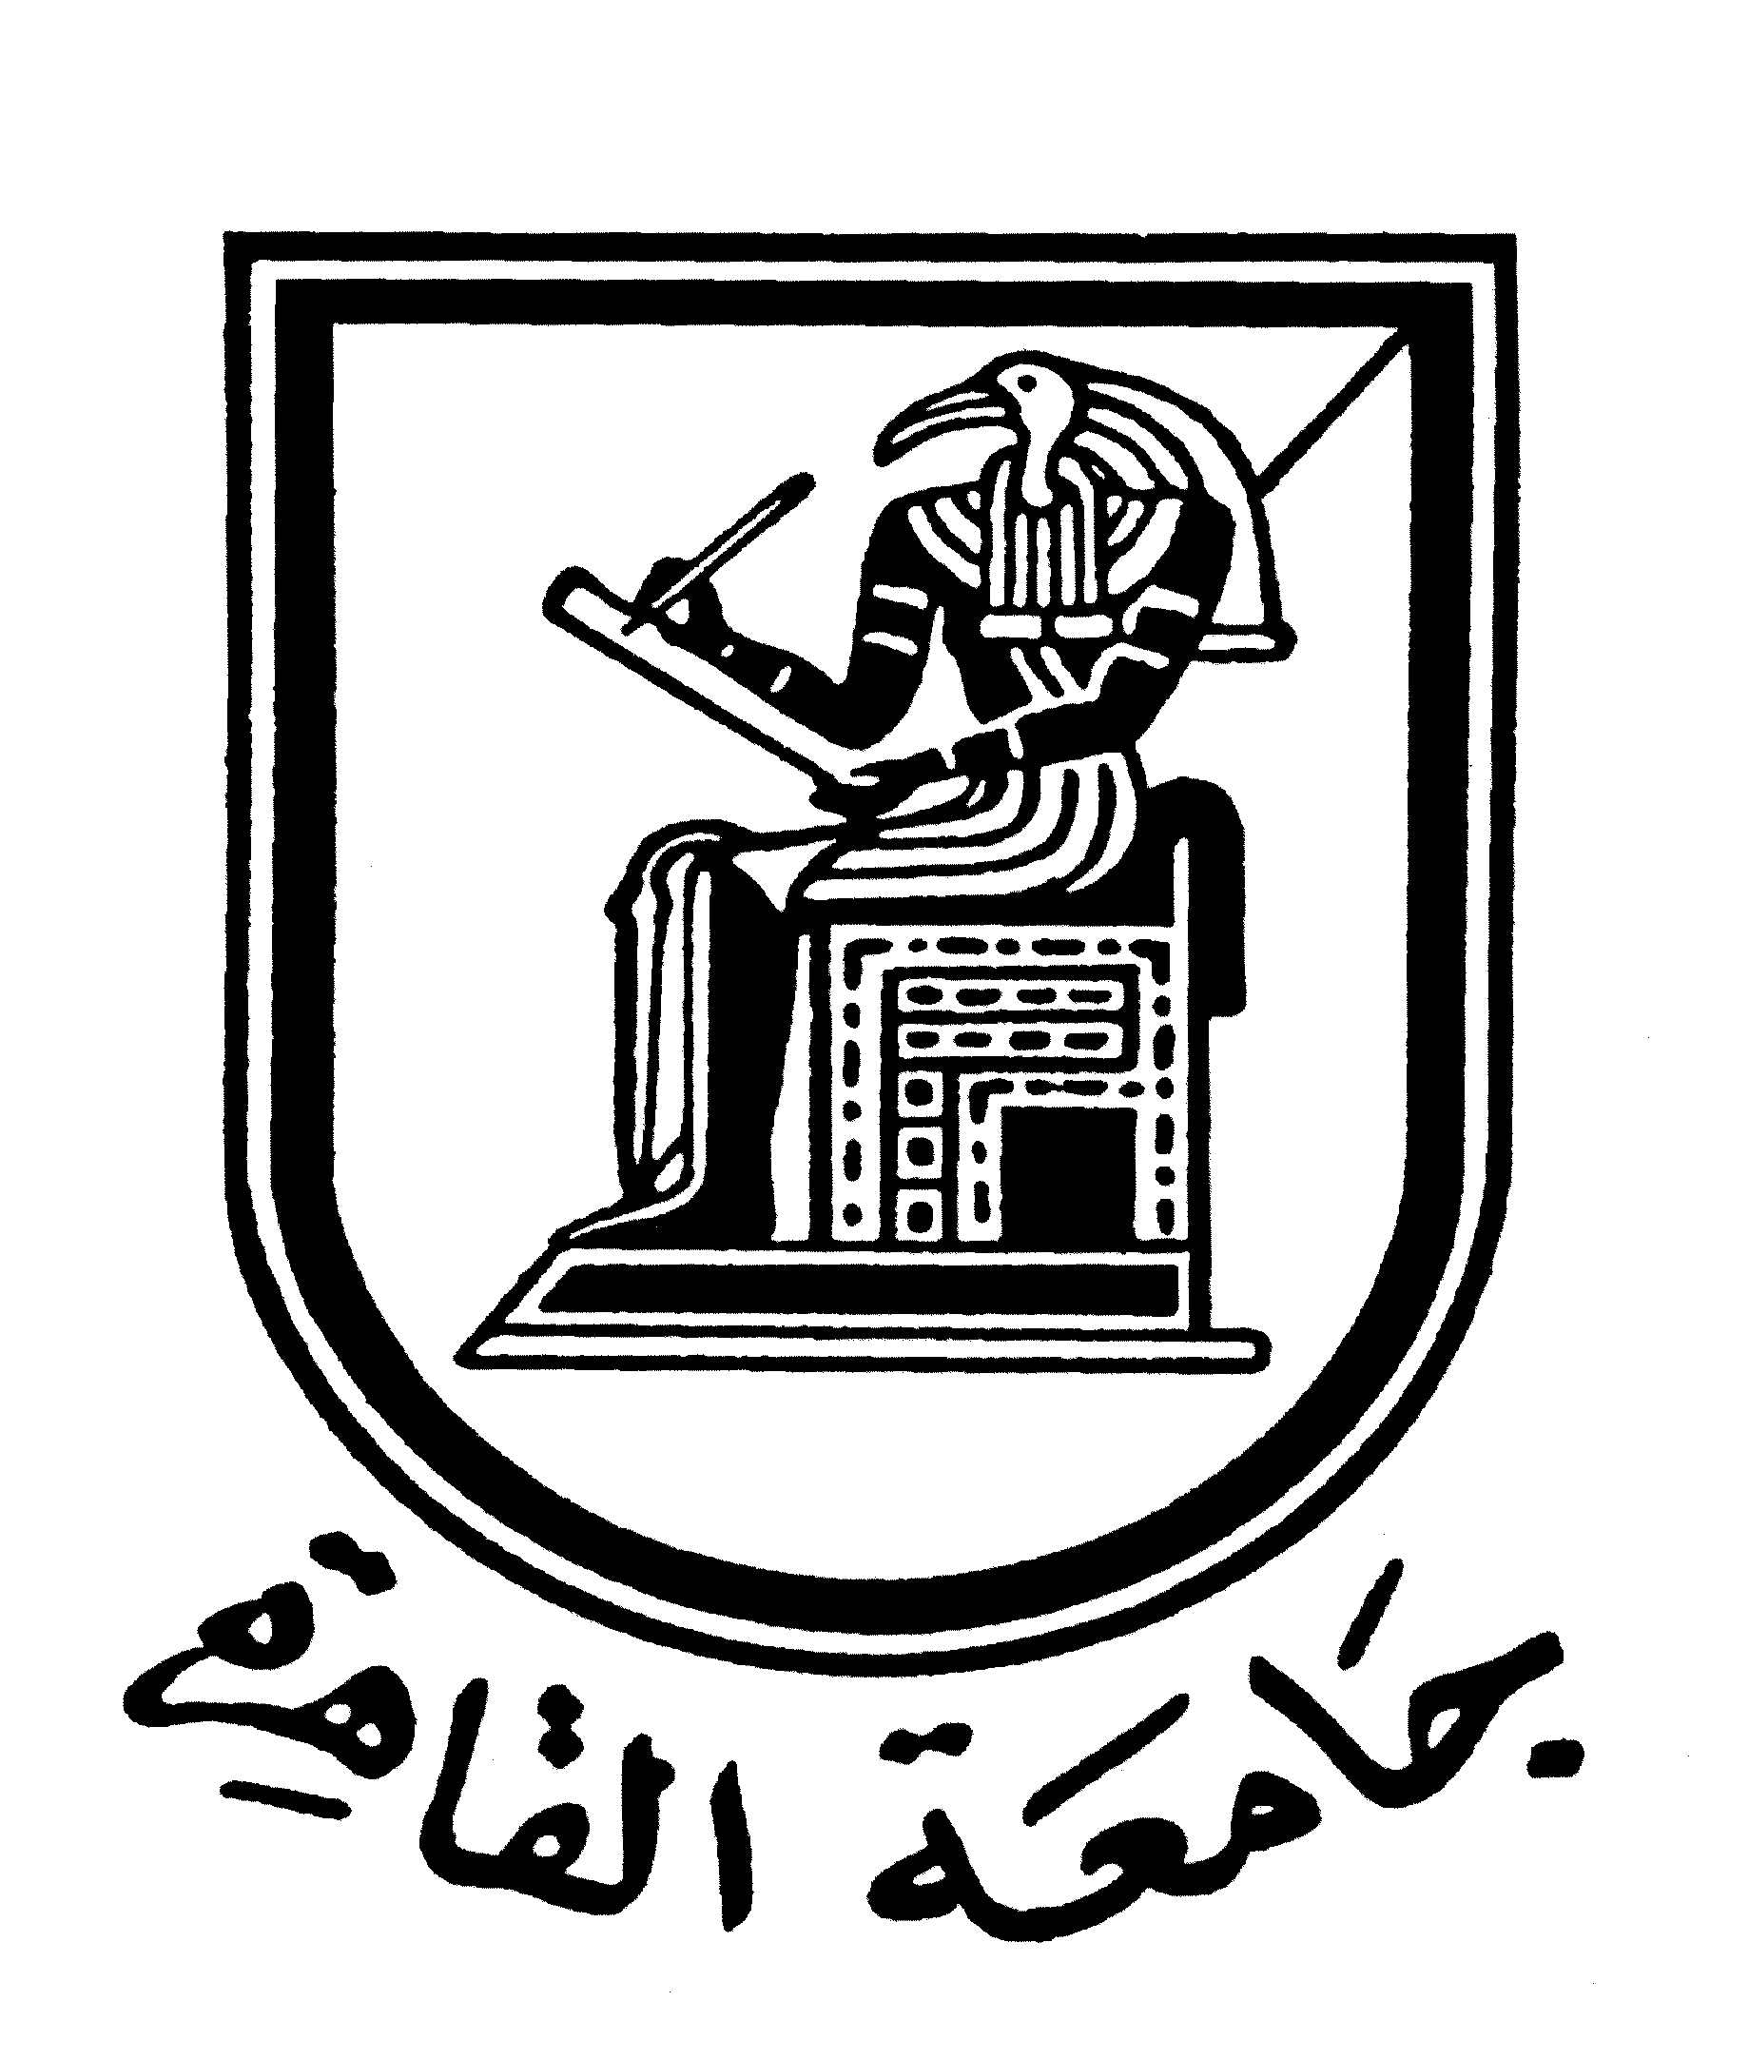 |  | 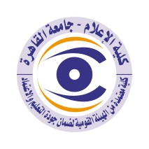

Brief CV of the members of the academic staff
1- Name: Nahed Ahmed Fouad Abou Al-Ayoun.
2- Academic department: Journalism
3-Academic degree: PhD in Media
4- The title of the master’s thesis, the year and the entity it was obtained from:
Al-Jehad Newspaper by the Faculty of Mass Communication, Cairo University, 1978.

5- The title of the doctoral thesis the year and the entity it was obtained from:
Evaluation of the Egyptian experience in academic preparation and professional training for journalists, 1988, Faculty of Mass Communication, Cairo University.

6- Courses taught in the Bachelor program:

7- The most important reference books issued to you benefiting from your academic research (no more than five books):

8- The five most recent academic researches that have been published:

9- The five most recent researches (Masters and Ph.D.) that I supervised:

10- The activities carried out in the faculty (other than teaching) and contribute to developing the educational process and serving students:
Participation in the faculty’s scientific conferences and training activities for Arab and African students, for example, the training course in Rabat, Morocco, as well as participating in supervising practical training for students of the journalism department in various press institutions during the years of adopting this training in the department’s curricula.

11- The most important leading positions that have been held:

12- The most important local and international awards obtained, the year when awarded and the entity awarded them:

Contact means:
E-mail :
Mobile: 01001699381

