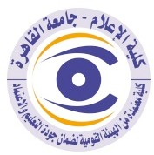 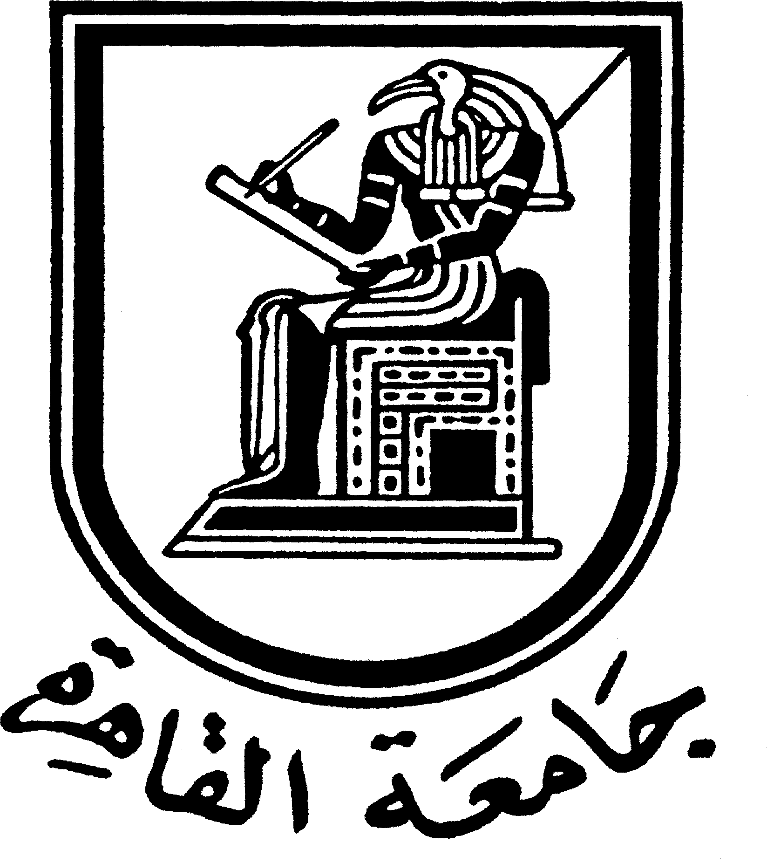

**Brief CV (of the members of the academic staff)**

**Name: Maha Mohammed Ragab AL-Wazier**

**Academic Department: Radio and Television**

**Academic degree: Teacher**

**The title of the master’s thesis, the year and the entity it was obtained from:**

The trends of the American public opinion towards the Arab-Israeli conflict and its relationship to interest in international and Israeli news: Follow-up study from 1948 until 2009 Faculty of Mass Communication, Cairo University

2011.

**The title of the doctoral thesis the year and the entity it was obtained from:**

Addressing political and social issues in women's cinema in the Middle East.

**Courses taught in the Bachelor program:**

Drama in Radio and Television

**The most important reference books issued by the faculty member to benefit from his scientific research (a maximum of five books):**

None

**The five most recent academic researches that have been published:**

“Framing and Internet in Egypt: How Tamarod(rebellion) used SNS in Mobilization", Transnational Worlds of Power Journal, Proliferation of Journalism and Professional Standards, vol. 1, issue 1, 2015

**The most recent five scientific theses (Master's and Ph.D.) that have been supervised:**

None

**Other activities of the member of the academic staff in order to develop the educational process and serve students other than the teaching activity:**

Supervising the practical training of the students of the Radio and Television Department.

**The most important leading positions that have been held:**

**The most important local and international awards obtained, the year when awarded and the entity awarded them:**

Mobile: 01003732078

E-mail mahaelwazir@gmail.com