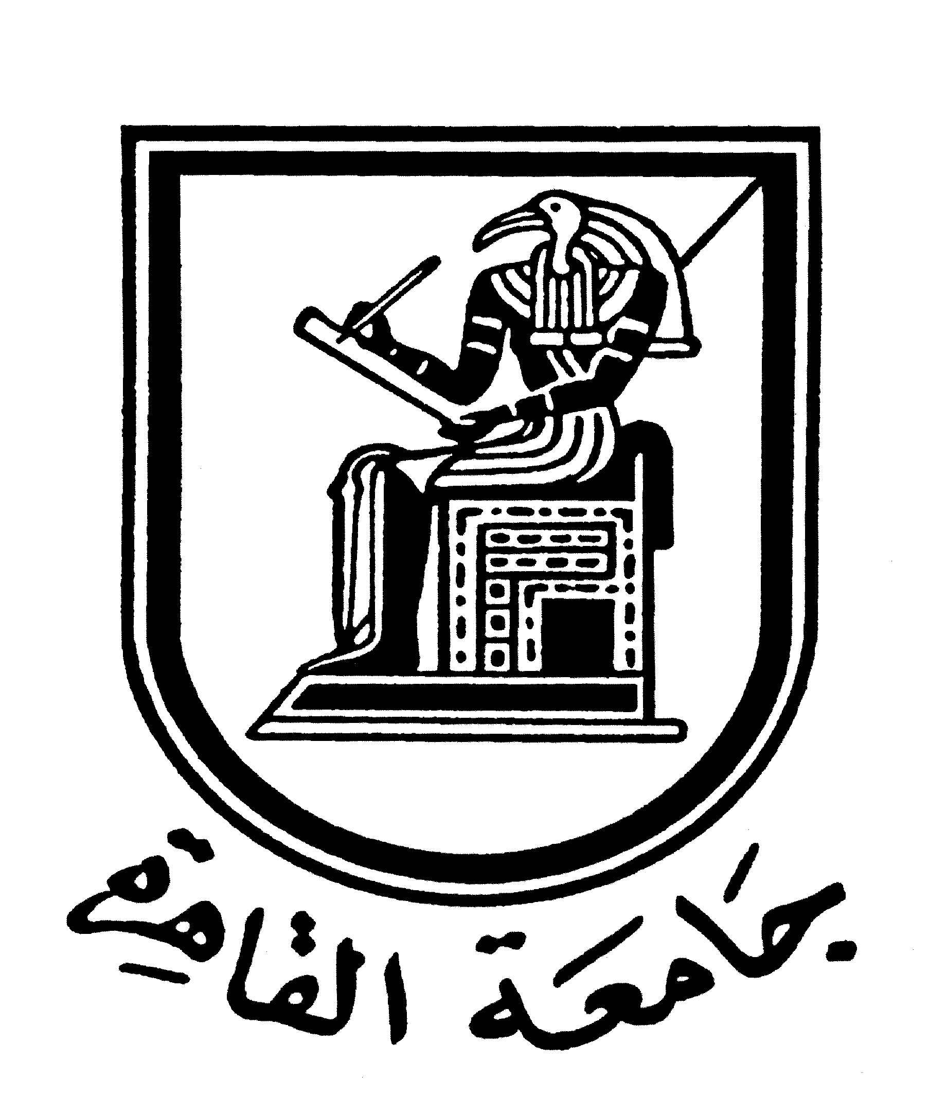 |  | 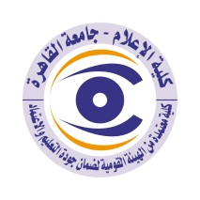

Brief CV of the members of the academic staff
- Name: Mohammed Mansour Mahmoud Mansour Hiba
- Academic department: Journalism
3-Academic degree:
4-The title of the master’s thesis, the year and the entity it was obtained from:
Islamic Press in Egypt-Faculty of Mass Communication, Cairo University, 1987.
5- The title of the doctoral thesis the year and the entity it was obtained from:
Islamic Press in Egypt 1952 -1981– Faculty of Mass Communication, Cairo University, 1996.
6- Courses taught in the Bachelor program:
Press Editing-Specialized Press-Media Language-Media and Development-Research Approaches.
The most important reference books issued to you benefiting from your academic research (no more than five books)
Islamic press in Egypt between Abdulnasser and Alsadat-Media Language-A special topic in journalism - Specialized Press- Journalism, Power and Islam in Egypt
8- The five most recent academic researches that have been published:

9- The five most recent researches (Masters and Ph.D.) that I supervised:

The activities carried out in the faculty (other than teaching) and contribute to developing the educational process and serving students
- The Secretary of Egyptian Magazine of Public Opinion Research.
- Military affairs editor at Al-Ahram newspaper
- Head of the news department at Al-Ahram Evening Newspaper
- Head of the local bureau of Al-Ahram Evening Newspaper
- Member of the editorial board of Al-Ahram Evening Newspaper
- Worked as part of a team of media advisors for an international development project in Egypt.
11- The most important leading positions that have been held:
The head of Journalism department in Faculty of Mass Communication- Cairo University (2008-2009).
12- The most important local and international awards obtained, the year when awarded and the entity awarded them:

Contact means:
E-mail:
Mobile:

