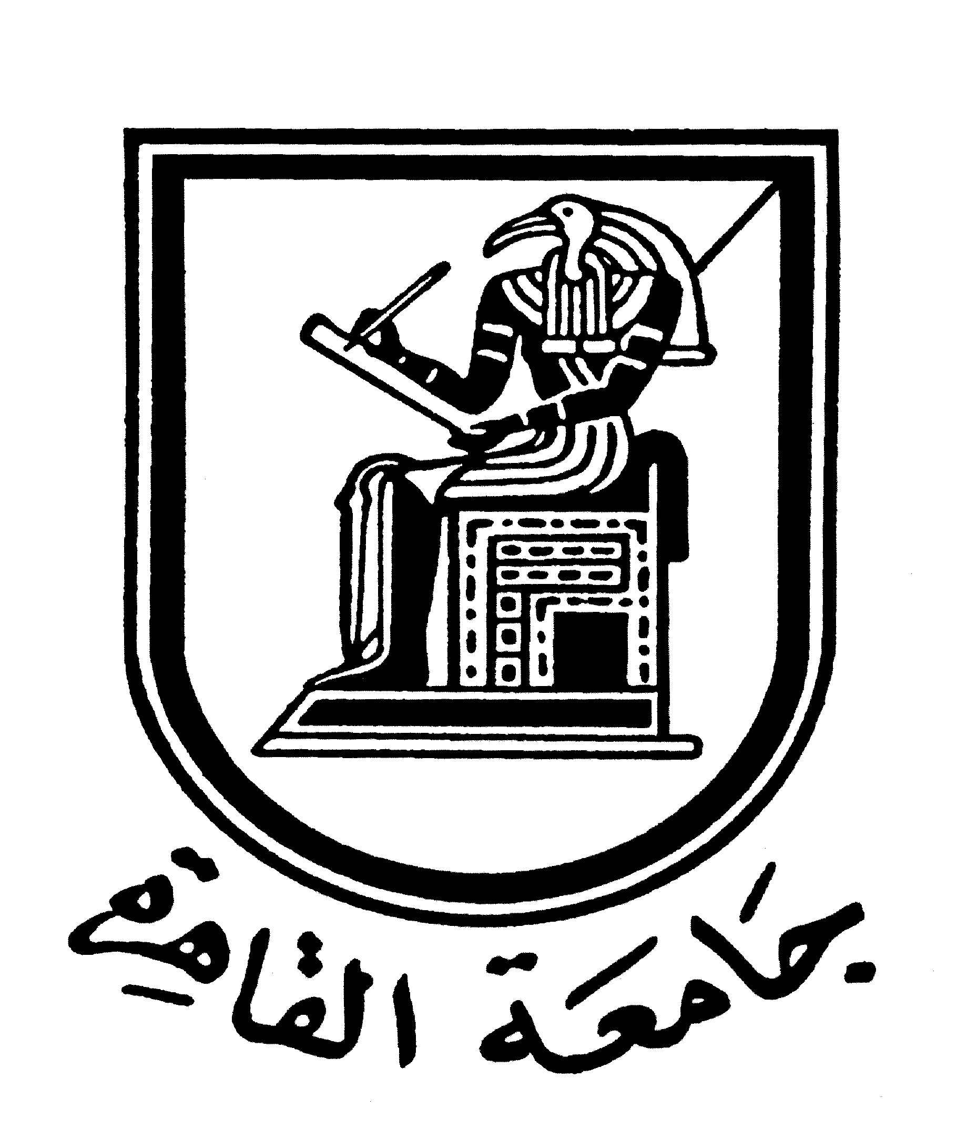 |  | 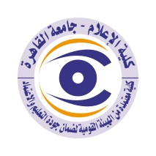

Brief CV (of the members of the academic staff)
- Name: Mohammed Mohammed Mohana
- Academic Department: Radio and Television
3-Academic degree: PhD
4-The title of the master’s thesis, the year and the entity it was obtained from:
The relationship between TV drama and psychosomatic diseases - an empirical study on the relationship of drama to blood pressure disease in the Egyptian countryside, Cairo University, Faculty of Mass Communication, 1985 , with “Excellent” degree.

5- The title of the doctoral thesis the year and the entity it was obtained from:
Issues dealt with by the opinion programs on the Egyptian radio and television, Cairo University, Faculty of Mass Communication, 1994, appreciation “first class honour”.

6- Courses taught in the Bachelor program:
- Communication technology (4 radio and television department)
- Vocabulary and vocals (3 radio and television department)

7- The most important reference books issued by the faculty member to benefit from his scientific research (a maximum of five books):
- Media Language
- Radio and TV directing, in partnership with Prof. Dr. Sami Al-Sharif
- Introduction to radio and audio-visual media in partnership with Prof. Dr. Magy El Halawani
- Press and TV photography
- Public opinion and propaganda

8- The five most recent academic researches that have been published:
- A research in English on the electronic networks of the Egyptian media, presented at the International Conference of Scientific Editors.
- A joint research for regional media.
- A joint research on the media and family planning.
- Research on the effects of electronic networks: The impact of electronic innovations on the means of communication and its audience
- Participation in a research on public relations in the UAE
- Participation in research on local media and its role in development

9- The most recent five scientific theses (Master's and Ph.D.) that have been supervised:
Co-supervision on a number of theses in Radio division.

10- Other activities of the member of the academic staff in order to develop the educational process and serve students other than the teaching activity:
- Establishing the first digital image lab in the university in Faculty of Mass Communication.
- Supervising the project of a university centre for graphics and digital image in the Fifth International Exhibition of Small Projects.
- Supervising the faculty studios for two years.
- Radio news editorship.
- Translator and editor for the foreign department of Al-Ahram newspaper.
- Membership of the Scientific Committee to set technical specifications for the faculty studios.
- Supervising the Scientific Assembly of the Faculty.
- Lecturer and TV trainer for many organizations such as:
- Nile Centres affiliated to the State Information Service.
- The Arab Organization for Development, Culture and Science.
- Cadre Preparation Institute at the Ministry of Administrative Development.
- Arak Institute "6 October Magazine"
- Supervisor of the university youth program presented by Dubai Radio for 4 years.
- Producer of the “Information That Interests You” program, a daily program presented by the Sultanate of Oman Radio on water issues
- Member of the International Federation of Scientific Editors in Italy

11- The most important leading positions that have been held:
- Head of the Communication Technology Department at Al Jazeera University in Dubai.
- Head of the Media Department at the University of Tabuk, Saudi Arabia, and press advisor to the president of the university.
- Media expert for the Ministry of Water Resources in the Sultanate of Oman, and media advisor to its Minister.

12- The most important local and international awards obtained, the year when awarded and the entity awarded them:
- Multiple literary prizes "poetry" with the broadcast and publication of dozens of poems in the Egyptian and Arab media.
- Producer and director of documentary films, including "Women and the University in 100 Years”
- Author of the operetta "An Emirati", which is broadcast on Emirati TV stations and YouTube.
- Member of juries in various art festivals, including the Cairo Arab Television Festival and the Dubai Festival for Local Television Programs.
- Certificates of appreciation from the Ruler of Dubai, the UAE University, the Sultanate of Oman, the Kuwaiti Ministry of Information, and the National Commission for the Protection and Development of Wildlife in Saudi Arabia.

Mobile: 01001107356
Email address: mahanymohamed@yahoo.com

