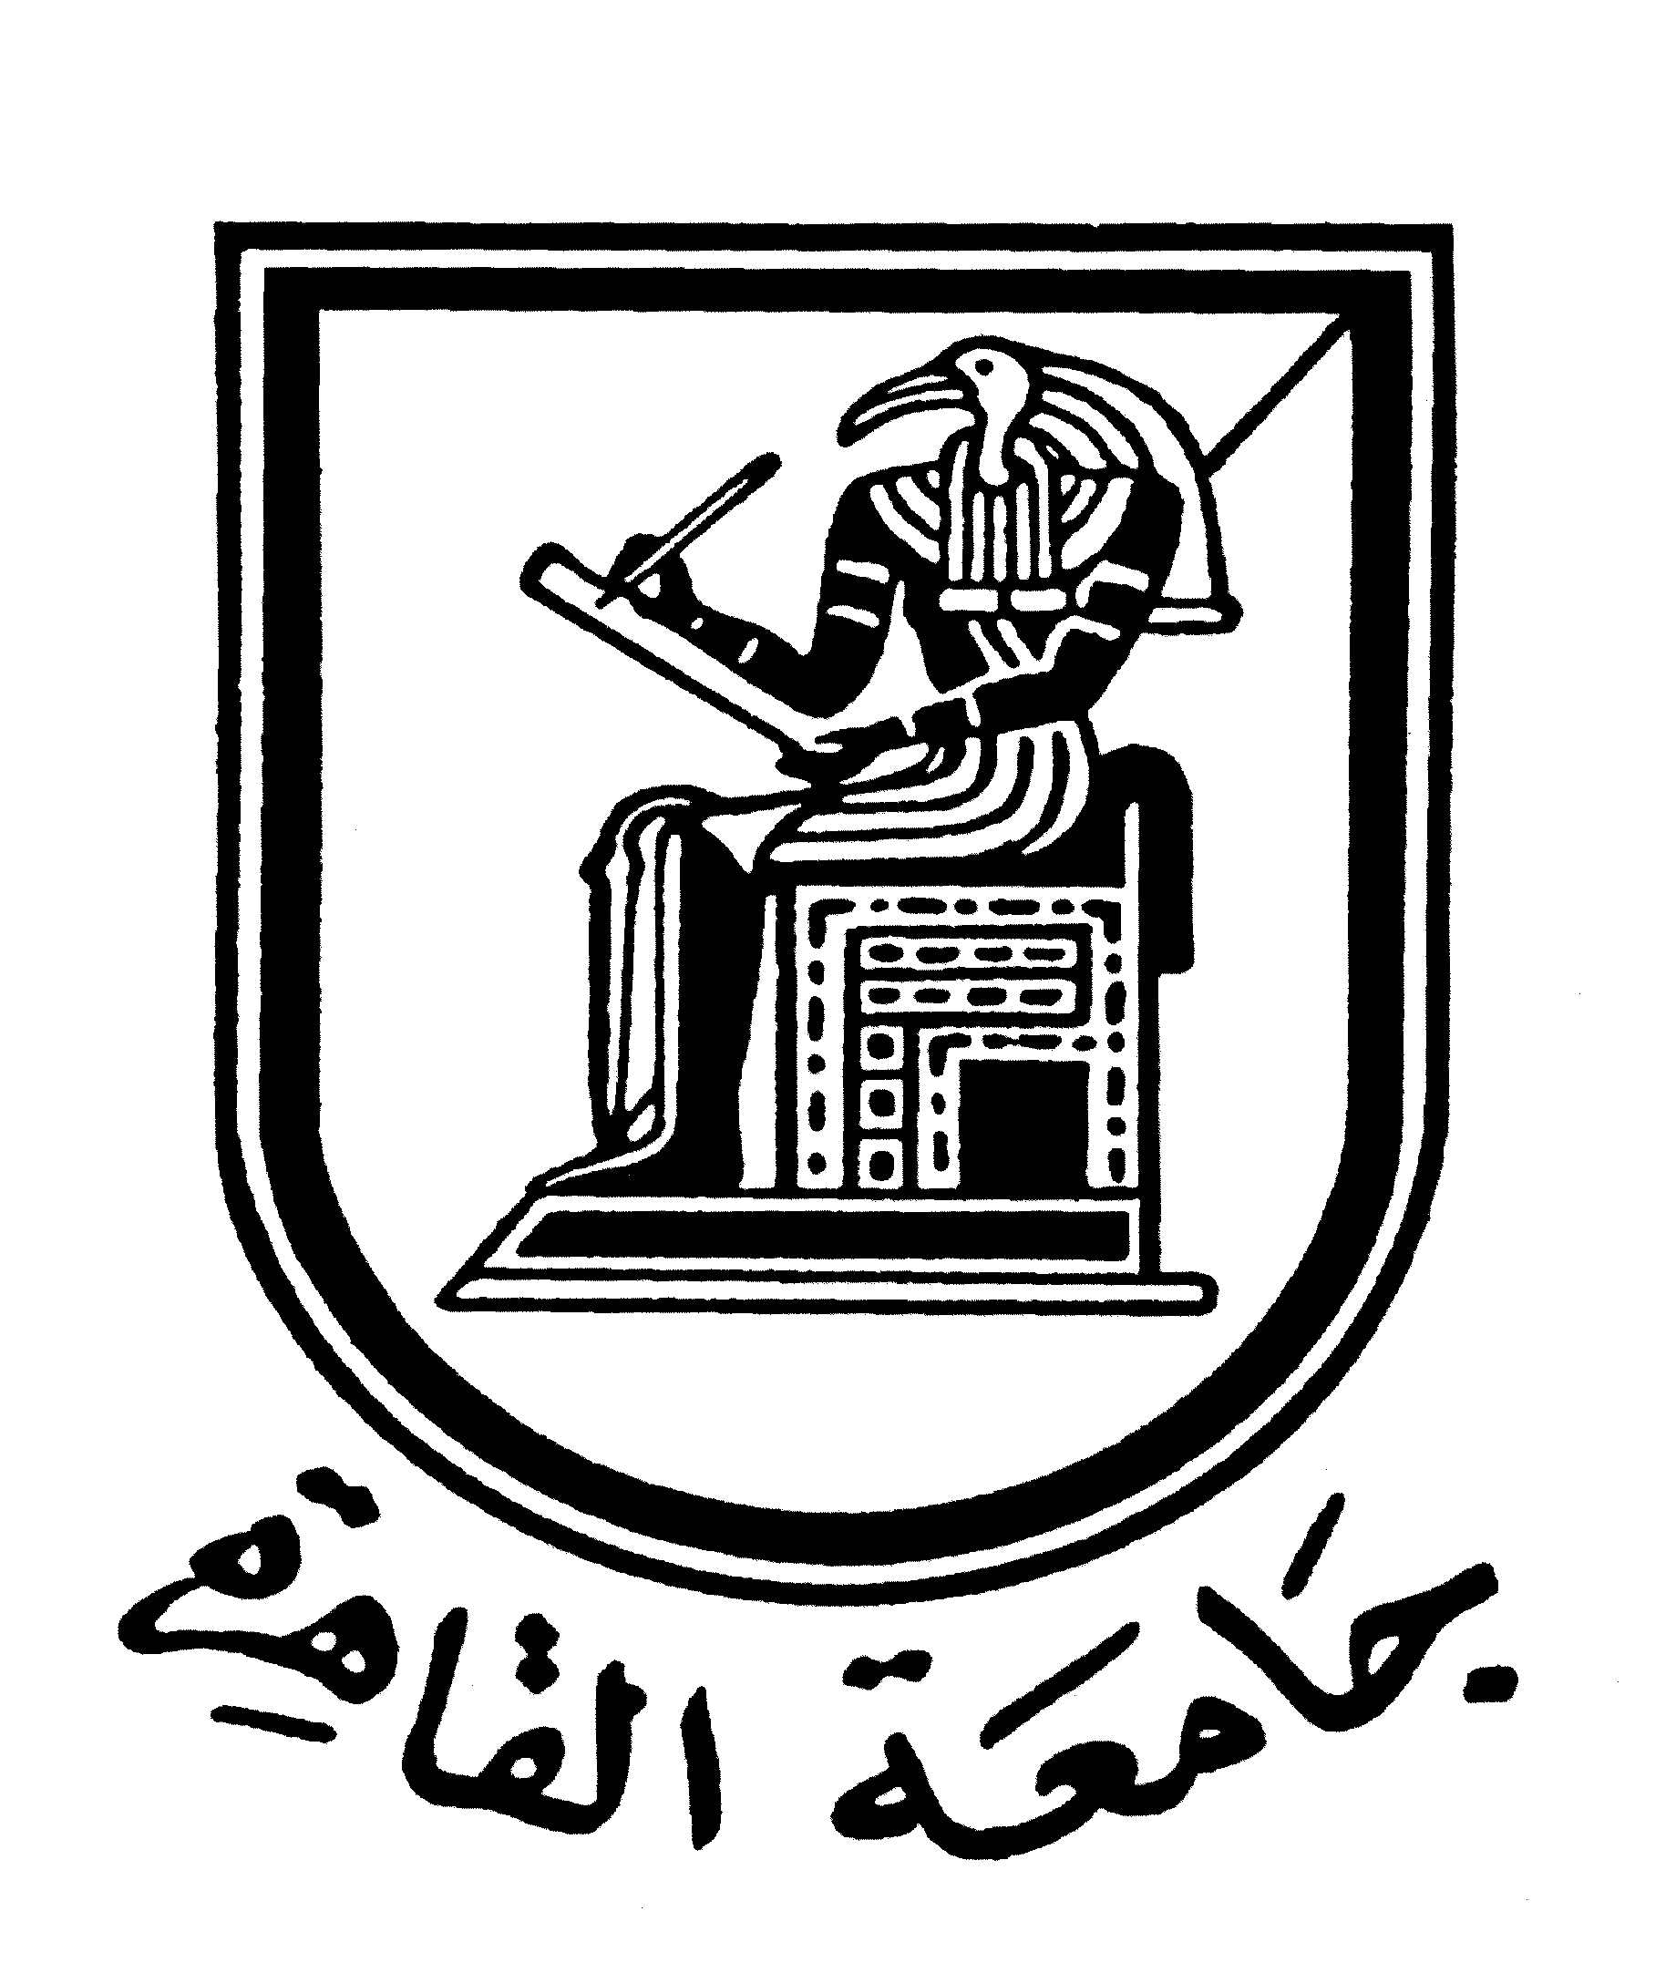 |  | 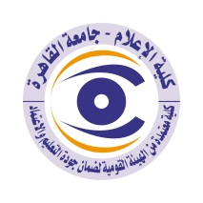

Brief CV (of the members of the academic staff)
- Name: Marian Murad Anis Boutrous.
- Academic Department: Public relations and Advertising.
3-Academic degree: Teacher
4-The title of the master’s thesis, the year and the entity it was obtained from:
Thesis title: The Egyptian public's use of the mobile phone and its relationship to social interaction.
Year when master degree obtained: 2013
Entity where master degree obtained: Faculty of Mass Communication, Cairo University..
5- The title of the doctoral thesis the year and the entity it was obtained from:
Thesis title: The relationship between the use of social communication and the degree of awareness of the Egyptian people.
Year when doctoral degree obtained: 2018
Entity where doctoral degree obtained: Faculty of Mass Communication, Cairo University..
6- Courses taught in the Bachelor program:
Courses taught since I appointed as a teacher:
Media and Social Change.
Protocol and ceremonies.
General opinion.
Media and Society

7- The most important reference books issued by the faculty member to benefit from his scientific research (a maximum of five books): ............
8- The five most recent academic researches that have been published:
A research entitled “The role of the mobile phone in e-learning for Egyptian university students during the Corona pandemic. The research was accepted on August 4, 2021, and it was approved for publication in the issue of October-December 77 in the Egyptian Journal of Media Research.
9- The most recent five scientific theses (Master's and Ph.D.) that have been supervised
A master's thesis entitled The Effectiveness of Promotional Strategies for Building a New Brand. A seminar was held for the researcher Marina Atef in 2020, and the researcher is now preparing for the chapters of the thesis.
10- Other activities of the member of the academic staff in order to develop the educational process and serve students other than the teaching activity:
Supervising Graduation Projects:
- A commercial marketing project for undergraduate students entitled "The Pharaohs Village" for the year 2009.
- A political marketing graduation project for undergraduate students entitled "Political Participation" for the year 2011.
- A political marketing graduation project for undergraduate students entitled "January Revolution" for the year 2011.
- A commercial marketing project for undergraduate students entitled “Chantelle Maria” for the year 2012.
- A commercial marketing project for undergraduate students entitled "Fagnoon Village" for the year 2013.
- A touristic marketing graduation project for undergraduate students entitled "Khayamia neighbourhood” for the year 2015.
- A social marketing project for undergraduate students entitled “No for Electronic Games” for the year 2016.
- A social marketing project for undergraduate students entitled “Two Rings Only” about marriage costs for the year 2017.
- A social marketing project for undergraduate students entitled “Companion” about animal welfare for the year 2019.
- A social marketing project for undergraduate students entitled "At the Edge" for mental health for the year 2020.
- A social marketing project for undergraduate students entitled "Never too Late" for achieving your dream and purpose for the year 2021.
- Currently supervising a social marketing project for a bachelor's student entitled "Mattakhash” (Don`t Complicate it) to spread positive energy.
- A graduation project in the electronic master's entitled "The impact of awareness campaigns through the social networking site Face book on the citizen's behaviour towards the Corona crisis".
- A graduate project in the electronic master's program entitled "The foreign policy of the United States of America and its impact on the mental image of Trump among the Egyptians.”
Training:
- Supervising the “Organizing Special Events” training for second and third year students in the Public Relations and Advertising Department in 2021.
Quality:
- Working as the coordinator of department of public relations and Advertising within the International Accreditation Team.
Training courses taken:
- Google Digital Marketing Basics Course.
- Google's "Transforming Business to the Internet" course.
- Enhance your online presence from Google.
- Course "Promoting a business through advertising on the Internet" from Google.
- Google's Expanding Business to Other Countries course.
- Google Mobile Customer Reach Course.
- Google's "Promoting a Business with Content" course.
- Google Course "Understanding Customer Needs and Behaviours on the Internet".
- The "International Computer Driving License" ICDL course from the Central Library of Cairo University.
- "Journalist Skills" course from the BBC.
- "New Media" course from the Centre for Social and Criminal Research.
- Electronic journalism course from the Deutsche Welle Foundation.
- Foundations of statistical analysis of SPSS data from the Statistics Centre.
- An advanced course in statistical analysis of SPSS data in media research from the College of Mass Communication.
- "Quality Standards in the Teaching Process" course from the University Teacher Preparation Centre at Cairo University.
- "Effective Presentation" course from the University Teacher Preparation Centre at Cairo University.
- Effective Communication course from the University Teacher Preparation Centre at Cairo University.
- "Competitive Researches Projects" course from the University Teacher Preparation Centre at Cairo University.
- "Profession Behaviours and Manners” course from the University Teacher Preparation Centre at Cairo University.
- "Scientific Research Ethics" course from the University Teacher Preparation Centre at Cairo University.
- "Effective Teaching Skills” course from the University Teacher Preparation Centre at Cairo University.
- “The Use of Technology in Teaching” course from the University Teacher Preparation Centre at Cairo University.
- “International Publication of the Scientific Researches” course from the University Teacher Preparation Centre at Cairo University.
- "Accredited Hours Systems” course from the University Teacher Preparation Centre at Cairo University.
- "Scientific Conferences Organizations" course from the University Teacher Preparation Centre at Cairo University.
- “Examination Systems and Students Correction” course from the University Teacher Preparation Centre at Cairo University.
- “Critical Thinking” course from the University Teacher Preparation Centre at Cairo University.
- "The Foundations of Integrated Education” course from the University Teacher Preparation Centre at Cairo University.
- Effective Presentation Course from Faculty of Mass Communication, Cairo University.
- Montage via the usage of Final Cut Program Course from Cairo University.
- Photo Editing via Photoshop Program Course from Cairo University.
- Training Course for working on Microsoft Team Platform from Cairo University.
- Training Course for working on Black Board Platform from Faculty of Mass Communication, Cairo University.
- “Intro to Digital Press” course from Reuters.
Seminars:
A symposium for students of the Faculty of Commerce in etiquette entitled "You are so Courteous".
Contributions:
- Participated in a team in summarizing all the messages at the Faculty of Mass Communication from its inception until 2008.
- Participated in a team in summarizing a number of years of scientific journals and conferences at the Faculty of Mass Communication.
- Participation in the "Advertising Industry Harvest 2020" celebration with the department's faculty and students.

11- The most important leading positions that have been held:.

12- The most important local and international awards obtained, the year when awarded and the entity awarded them:
An award presented by Tariq Nour in 2014 for the best master's thesis for the year 2013.

Mobile: 01009722206
Email: marian.masscomm@gmail.com
Edited on 9th of December 2021.

