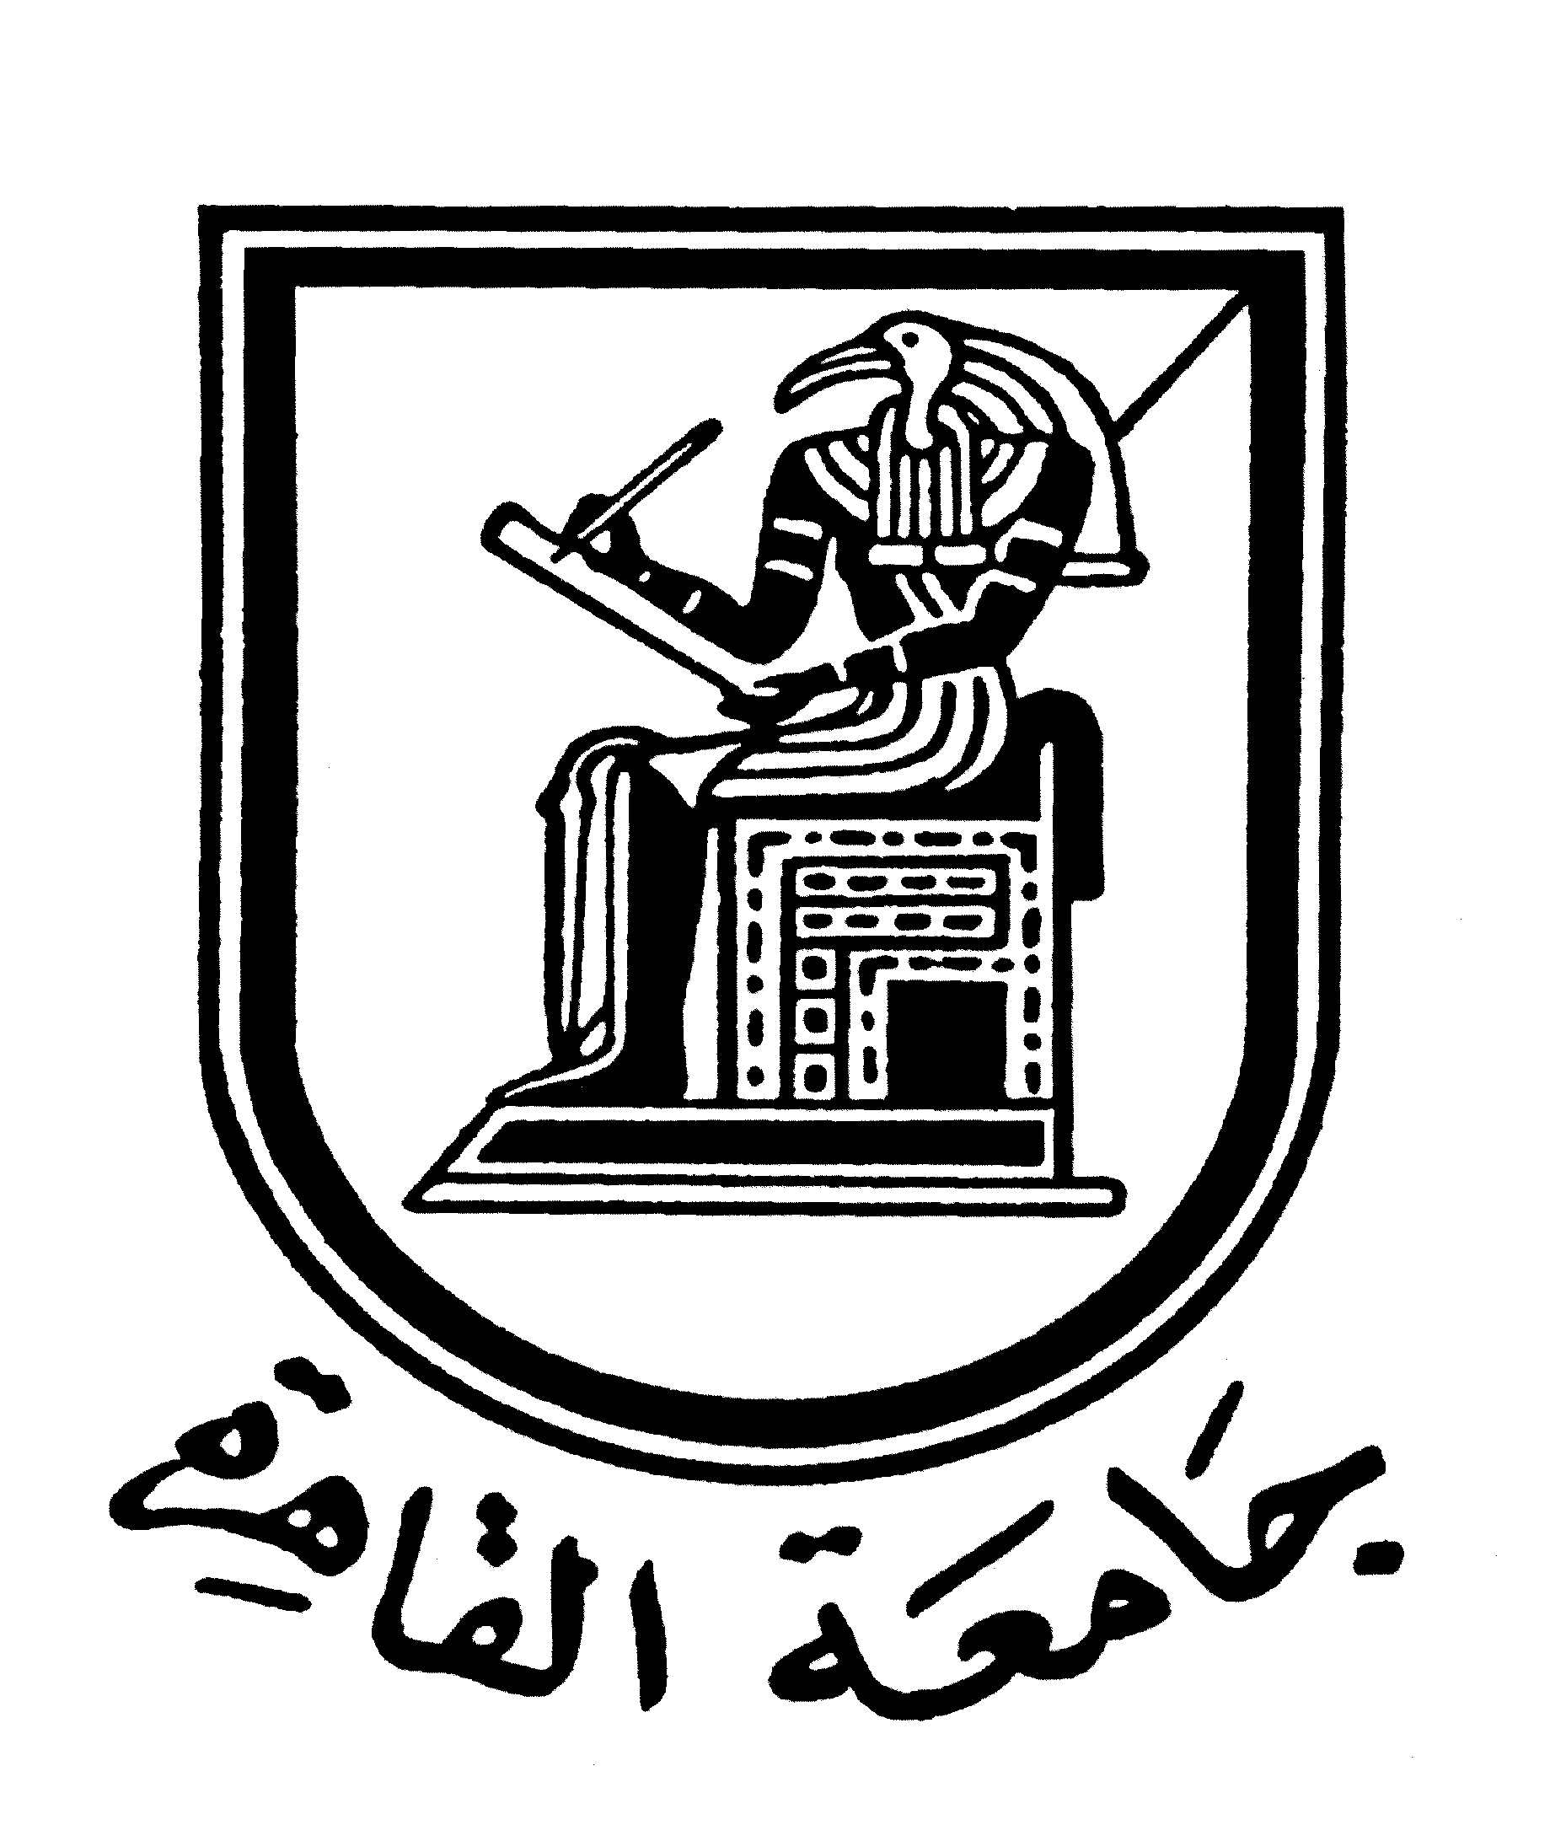 |  | 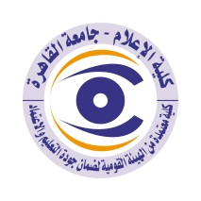

Brief CV (of the members of the academic staff)
1- Name: Margriet Samir Sawirs Makar
2-Academic Department: Journalism
3-Academic degree: PhD
4-The title of the master’s thesis, the year and the entity it was obtained from:
Factors affecting job satisfaction of female contacts in the Egyptian press / Cairo University year 2005.
5- The title of the doctoral thesis the year and the entity it was obtained from:

The relationship between the characteristics of the communicators and the methods of editing news articles in the Egyptian daily newspapers / Cairo University, 2011.

6- Courses taught in the Bachelor program:
Press editing
Press Institutions Management.
7- The most important reference books issued by the faculty member to benefit from his scientific research (a maximum of five books):
None.
8- The five most recent academic researches that have been published:
None.
9- The most recent five scientific theses (Master's and Ph.D.) that have been supervised:
- The development of the political and social concepts in the press speech since January revolution 2011: Analytic study.
(The researcher Al-Zahraa Ahmed Rashad) 2019.
- The relationship of the professional training of the communicator with the methods of employment and levels of writing the art of the feature in the daily newspapers.
(The researcher Moahmmed Khalil) 2019.
10- Other activities of the member of the academic staff in order to develop the educational process and serve students other than the teaching activity:
- Supervising the specialized research projects and the graduation projects of the fourth grade.
- Supervising the training of students in the university's voice newspaper.
11- The most important leading positions that have been held:
None.
12- The most important local and international awards obtained, the year when awarded and the entity awarded them:
None.
Mobile: 01009722206
Email: MARGRITSAMIR@GMAIL

