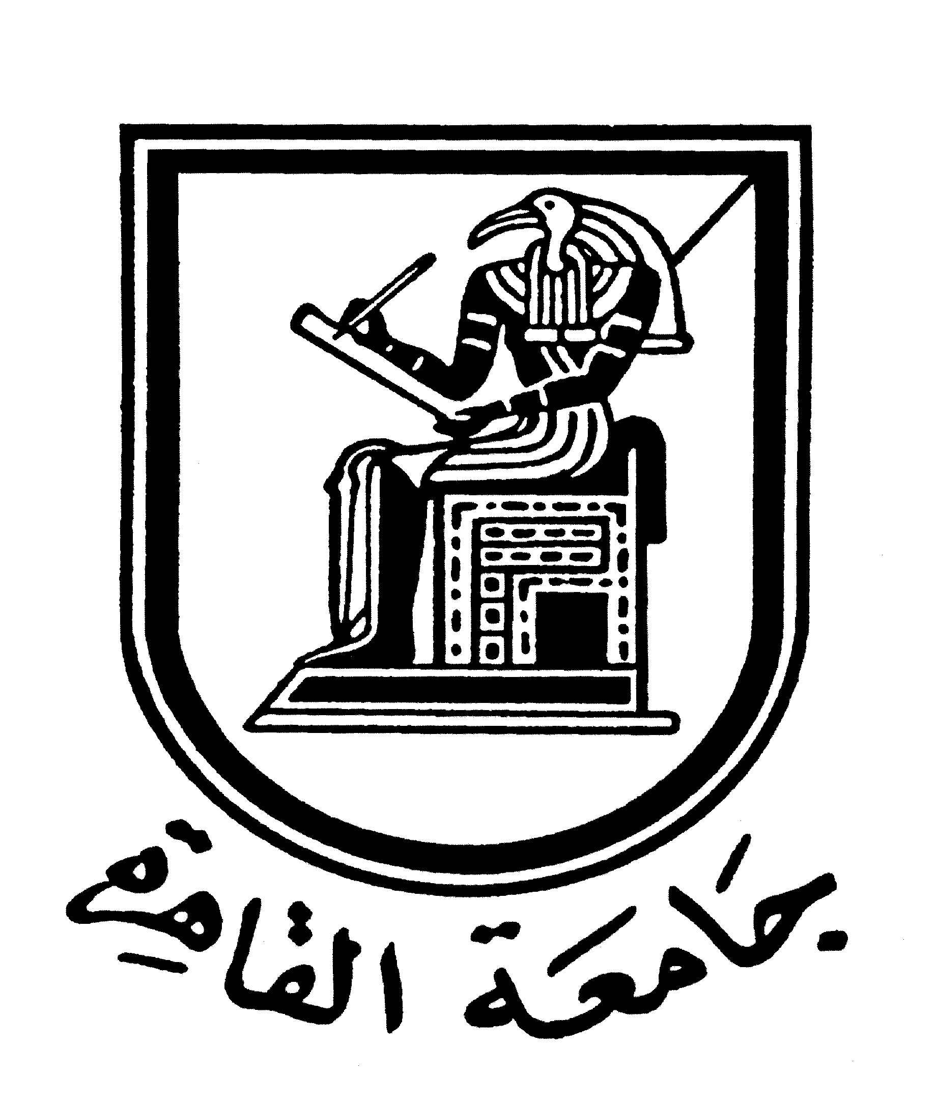 |  | 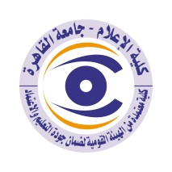

Brief CV (of the members of the academic staff)
- Name: Kariman Mohammed Farid Ali Sadek.
- Academic Department: Public Relation and Advertising.
- Academic degree: Associate Professor
- The title of the master’s thesis, the year and the entity it was obtained from:
“Public Relations with the Internal Public", a field study on a sample of establishments in the industrial and insurance sectors, 1985, with an excellent grade, Cairo University - Faculty of Mass Communication, Department of Public Relations and Advertising.
- The title of the doctoral thesis the year and the entity it was obtained from:
The Social Responsibility of Public Relations in Economic Units "A field study on a sample of public and private sector companies", 1990, with first honour, Cairo University - Faculty of Mass Communication, Department of Public Relations and Advertising.
6- Courses taught in the Bachelor program:
- Corporate Communication.
- Public Relations Department
- A special topic in public relations.
- Writing for public relations.

7- The most important reference books issued by the faculty member to benefit from his scientific research (a maximum of five books):
1- Strategic Management for Corporate Sustainability: A Multidimensional Perspective, (in press), 2022.
2- Writing for Public Relations, Fourth Edition, (Cairo: Dar Al-Nahda Al-Arabiya, 2021).
3- Corporate Communication and the Challenges of Change, 3rd Edition, (Cairo: Dar Al-Nahda Al-Arabiya, 2019).
4- Public Relations Department between Strategic Management and Crisis Management, Fifth Edition (Cairo: World of Books; 2019).
5- Social responsibility and social marketing, second edition, (Cairo: Dar Al-Nahda Al-Arabiya, 2014).

8- The five most recent academic researches that have been published:
- Communication and Social Change in Egypt. Reality, and visions for the future “Applying to the issue of illiteracy”, the nineteenth international conference, Faculty of Mass Communication, Cairo University in cooperation with UNESCO, entitled “Media and the Culture of Democracy” (MILID Week Egypt 2013 ).
- Crisis Communication Management in Egypt, an analytical vision of the causes of stumbling...and ways to succeed, Conference on Crisis Media and the Media Crisis, Faculty of Mass Communication, Al-Ahram Canadian University, Second Annual Conference, March 19-21, 2013.
- Media and Women in Rural and Urban "An Applied Study on Egypt and Bahrain" 2006 A group study between the Women's Research Centre at the Faculty of Mass Communication and the Bahraini Centre for Strategic Studies. The researcher did the part related to the image of women in advertisements in both Egyptian and Bahraini television and newspapers.
9- The most recent five scientific theses (Master's and Ph.D.) that have been supervised:
- Rehab Abdel Moez, Employment of Political Opponents of Social Media as Platforms to Challenge Silence 2021 (Master).
- Hala El-Sayed Yousry, The Impact of Organizational Cultural and Communication Dimensions on the Sustainability of Egyptian Companies, 2020 (Master)
- Shaima Abdel-Sabour, Evaluating the Role of International Public Relations Activities in Forming the National Image, 2019 (Master)
- Walaa Massad Ismail, Ideological Media Discourse on Democracy Issues in Egypt: A Comparative Study between the Impact of Traditional and New Media on the Intellectual Constitution of the Public", 2020 (PhD).
- Hend Mohamed Ali, The relationship between the efficiency of the internal marketing process for the brand, and the attitudes of customers towards it, 2020 (PhD).

10- Other activities of the member of the academic staff in order to develop the educational process and serve students other than the teaching activity:
-Developer of the research plan axes of the Public Relations Department according to the National Strategy for Science, Technology and Innovation 20-30 (2020)
- Coordinator of the scientific seminar for the Department of Public Relations and Advertising 2014-2020.
- Member of the Board of Directors of the Faculty of Mass Communication Marketing Agency 2017-2019.
- Coordinator of the Postgraduate Program at the Department of Public Relations - Faculty of Mass Communication - Cairo University in accordance with the standards of scientific quality assurance" 2009.

11- The most important leading positions that have been held:
- Head of the Public Relations Department at the Modern University of Science and Technology 2007-2008.

Mobile: 01009722206
Email:karimanfarid@yahoo.com

