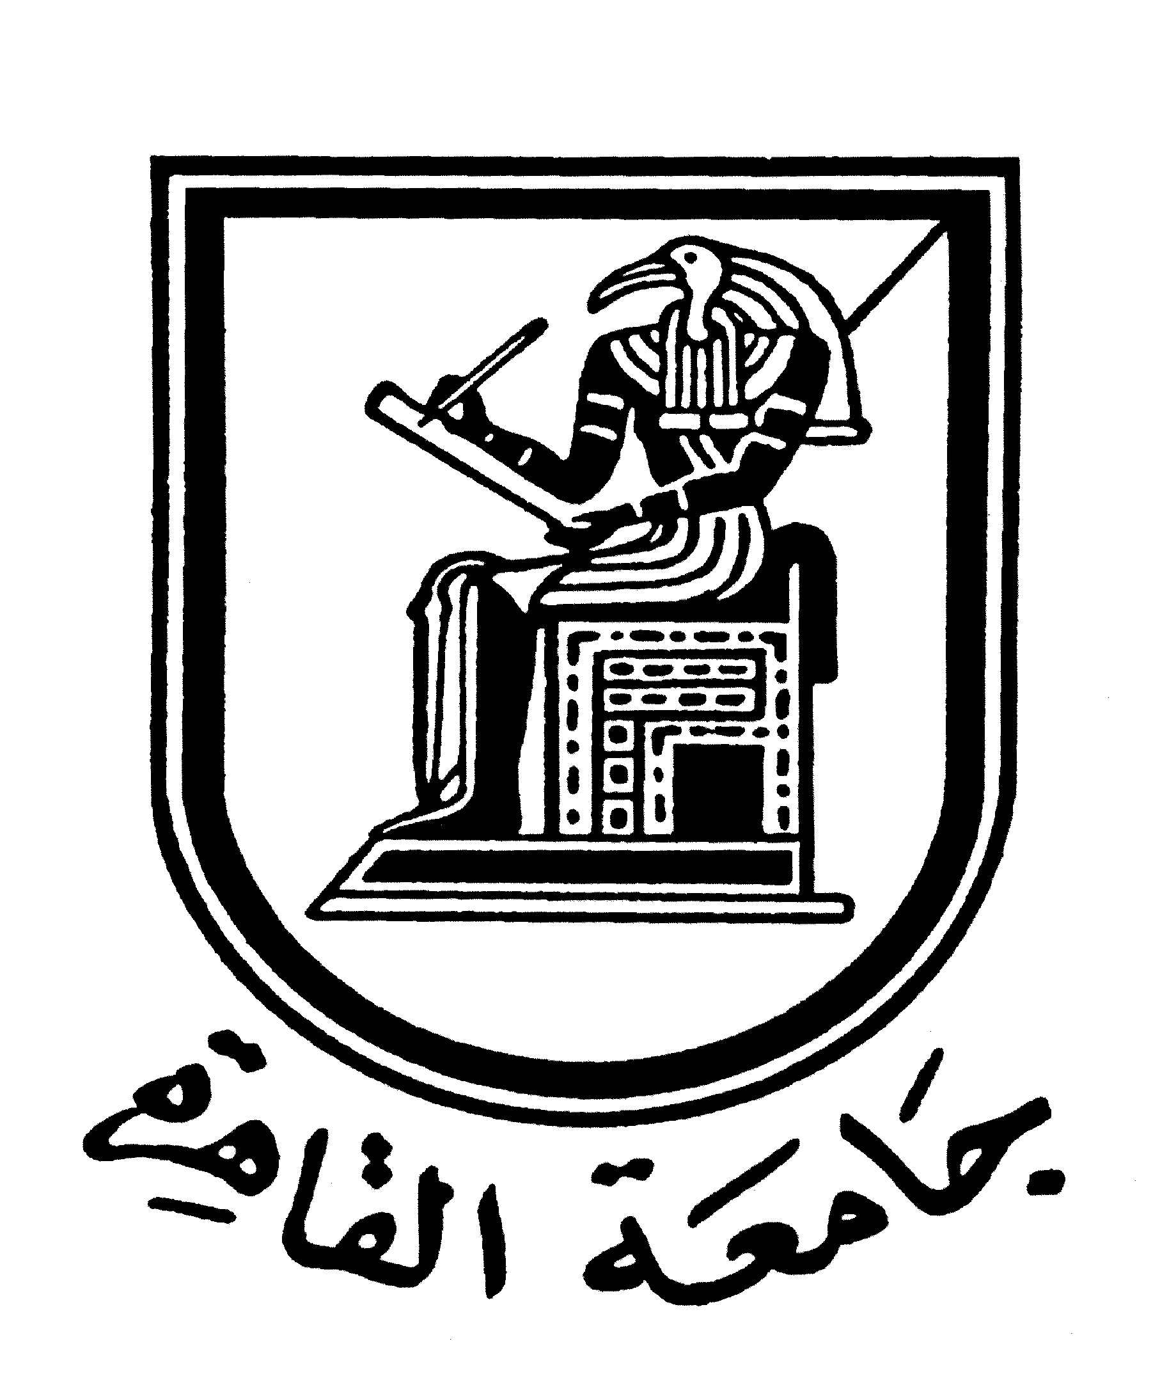 |  | 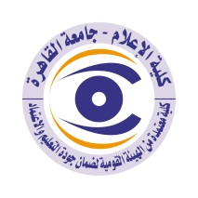

Brief CV (of the members of the academic staff)
Name: Eid Saad Raheel
Academic Department: Journalism
Academic degree: Teacher
The title of the master’s thesis, the year and the entity it was obtained from:
- The role of the press producer in supporting the creative aspects in the private newspapers release-2012.
The title of the doctoral thesis the year and the entity it was obtained from:
- The impact of the creativity in press production on the receiving of the editorial text. Quasi-experimental study -2020.
Courses taught in the Bachelor program:
- The principles of press production-Newspaper release-Magazine release-Design Foundations.
The most important reference books issued by the faculty member to benefit from his scientific research (a maximum of five books):
- Newspaper aesthetics. Creativity is a last-ditch effort to save the print press
The five most recent academic researches that have been published:

The most recent five scientific theses (Master's and Ph.D.) that have been supervised:

Other activities of the member of the academic staff in order to develop the educational process and serve students other than the teaching activity:
- Technical Director of Al-Dustour newspaper since, 2017.
- Technical Director of Al-Fajer newspaper since, 2007.
- Technical Director of Al-Tahrir newspaper since, 2015.
- Technical Director of Al-Tahrir newspaper since, 2014.
- Technical Director of Al-Dustour newspaper since, 2007 -2010.
- Working in the Technical Direction Department of Al-Midan Newspaper, 2007.
- Working in the Technical Direction Department of Al-Helwa Newspaper, 2006.
- Working in the Technical Direction Department of Al-Mal Newspaper, 2006-2007.
- Working in the Technical Direction Department of Souta Alomma sports Newspaper, 2004-2006.
- Designing many book covers such as (The Fall of the Gods - The Poison Scorpion - The Nights of Quraysh - The President's Cave - The War of the Generals... Secrets of the Struggle for the Presidency - Spying on the Copts - Generals and Revolutionaries - June 30 code)
- Press production coach at Akhbar Al Youm Center 2013-2014.
- Work in the Creative Team at An-Nahar TV Network 2015-2016.
- Participation in the production of a film about the daily press in Alexandria, 2007 in cooperation with the Media Development Program.
- Participation in the activities of the best newspaper design conference in Boston, USA, 2007.
- Technical Director of the University's Voice newspaper.
- Technical Director of the University Magazine.
- Contribute to the design of college publications.

The most important leading positions that have been held:

The most important local and international awards obtained, the year when awarded and the entity awarded them:

Mobile: 01003226161
Email address: eidraheel@yahoo.com

