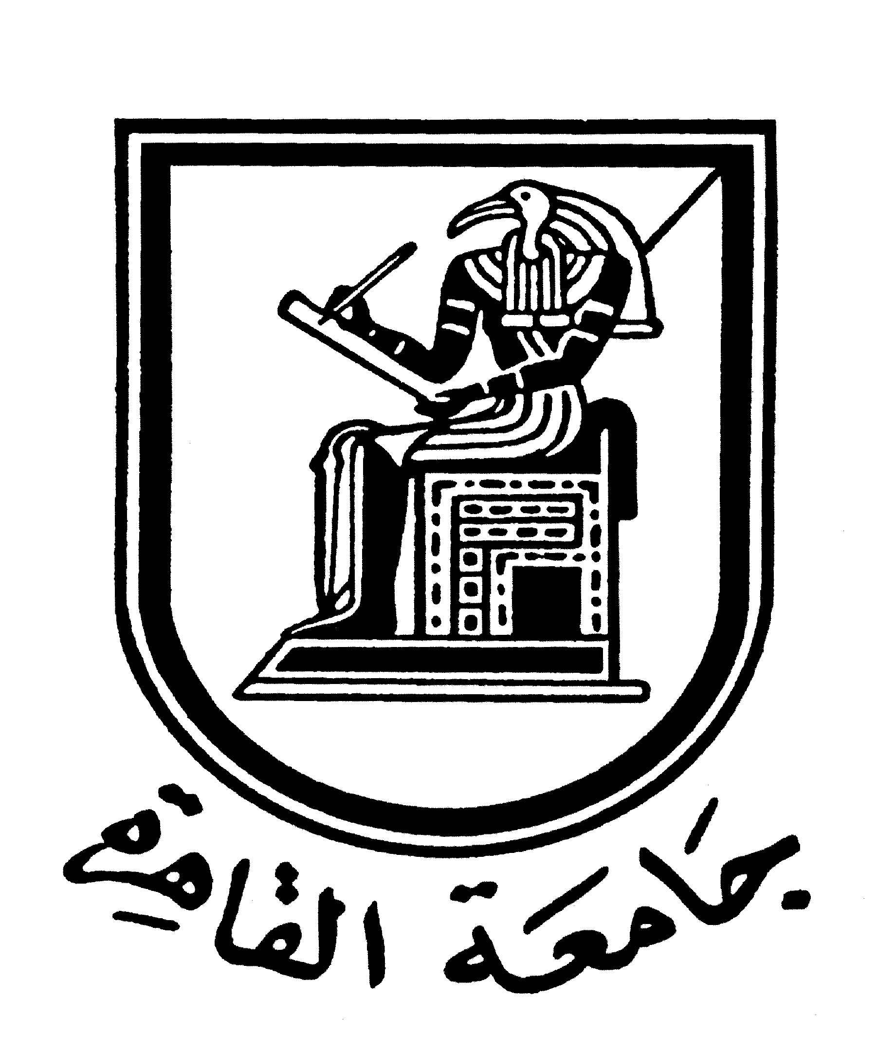 |  | 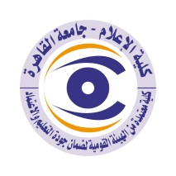

Brief CV (of the members of the academic staff)
- Name: Adel Fahmi Mohammed Ali
- Date of birth: Ash Sharqia Governorate, 11/7/1963
- Marital Status: Married
- Academic Department: – Department of Radio and Television - Faculty of Mass Communication - Cairo University.
- Academic degree: professor
- The title of the master’s thesis, the year and the entity it was obtained from:
- The role of the religious programs in educating the university youth, Master (1993) (Department of Radio and Television - Faculty of Mass Communication - Cairo University).
- The title of the doctoral thesis the year and the entity it was obtained from:

PhD: The role of the television in shaping the social awareness against crime (1995) (Department of Radio and Television - Faculty of Mass Communication - Cairo University)

Courses taught in the Bachelor program:
- Speech and vocals
- Media and Society
- International Media
- The most important reference books issued by the faculty member to benefit from his scientific research (a maximum of five books):
- Communicative and linguistic skills of the Media Professionals, Dar El Machreq, 2012.
- The media between the concerns of the individual and the issues of society, Dar El Machreq, 2012.
- International media and cultural acquaintance, Dar El Machreq, 2016.
- Pragmatics in the media: An introduction to linguistics. Dar El Machreq, 2020.
- Media and Terror: The Battle of Ink and Blood, Dar Gharib: 2020
The five most recent academic researches that have been published:
- The uses of the Internet by violent groups: a study in analysing the discourse of Al-Qaeda, Public Opinion Magazine, 2015. Published in the Egyptian Magazine of Public Opinion Research, July-September 2013 volume 12 issue 3.
- The development of audio-visual media in Egypt: Intermediate study in light of the strategic planning model, 2016.Published in the Scientific Journal of Radio and Television Research, Scientific Journal of Radio and Television Research, the eighth issue October December, 2016.
- Youth exposure to social networking sites and its relationship to the identity of the Internet generation and the generational gap, Published in the Egyptian Magazine of Public Opinion Research, Volume 16, the second issue April-June-2017.
- Viewers' preferences for serious and entertaining media content and its relationship to their feelings of optimism and pessimism. Published in the Scientific Journal of Radio and Television Research, the eleventh issue, July-September, 2017.
- Evaluating the effectiveness of radio and television training programmes, 2018, Published in the Egyptian Magazine of Public Opinion Research, Egyptian Magazine of Public Opinion Research, 2018
- The most recent five scientific theses (Master's and Ph.D.) that have been supervised:
- Ayat Ali Saad, (2022): The Image of the Teacher in Egyptian and American Films: A Comparative Study, Faculty of Mass Communication, Cairo University.
- Iman Bastawy, (2022) :Exposing the positions of terrorist and governmental groups and the attitudes of Egyptian youth towards them, Faculty of Mass Communication - University of Cairo.
- Sherine Hesham Maged, (2020) :Egyptian women exposure to Turkish series on Arab satellite channels and their relationship to changing their lifestyles, MA, Faculty of Mass Communication, Cairo University.
- Yasmine Hamdi Abdel-Zaher, (2018) :Television drama personalities influencing the formation of the behaviour of Egyptian youth, MA, Faculty of Mass Communication, Cairo University.

- Other activities of the member of the academic staff in order to develop the educational process and serve students other than the teaching activity:
- Trainer in the areas of communication skills, mental image, program preparation and presentation.
- Media consultant for more than one entity in Egypt and Saudi Arabia.
- The most important leading positions that have been held:
- Dean of a private institute for media and communication arts.
- The most important local and international awards obtained, the year when awarded and the entity awarded them:

Mobile: 01027285052
Email address: fahmi_adel@hotmail.com

