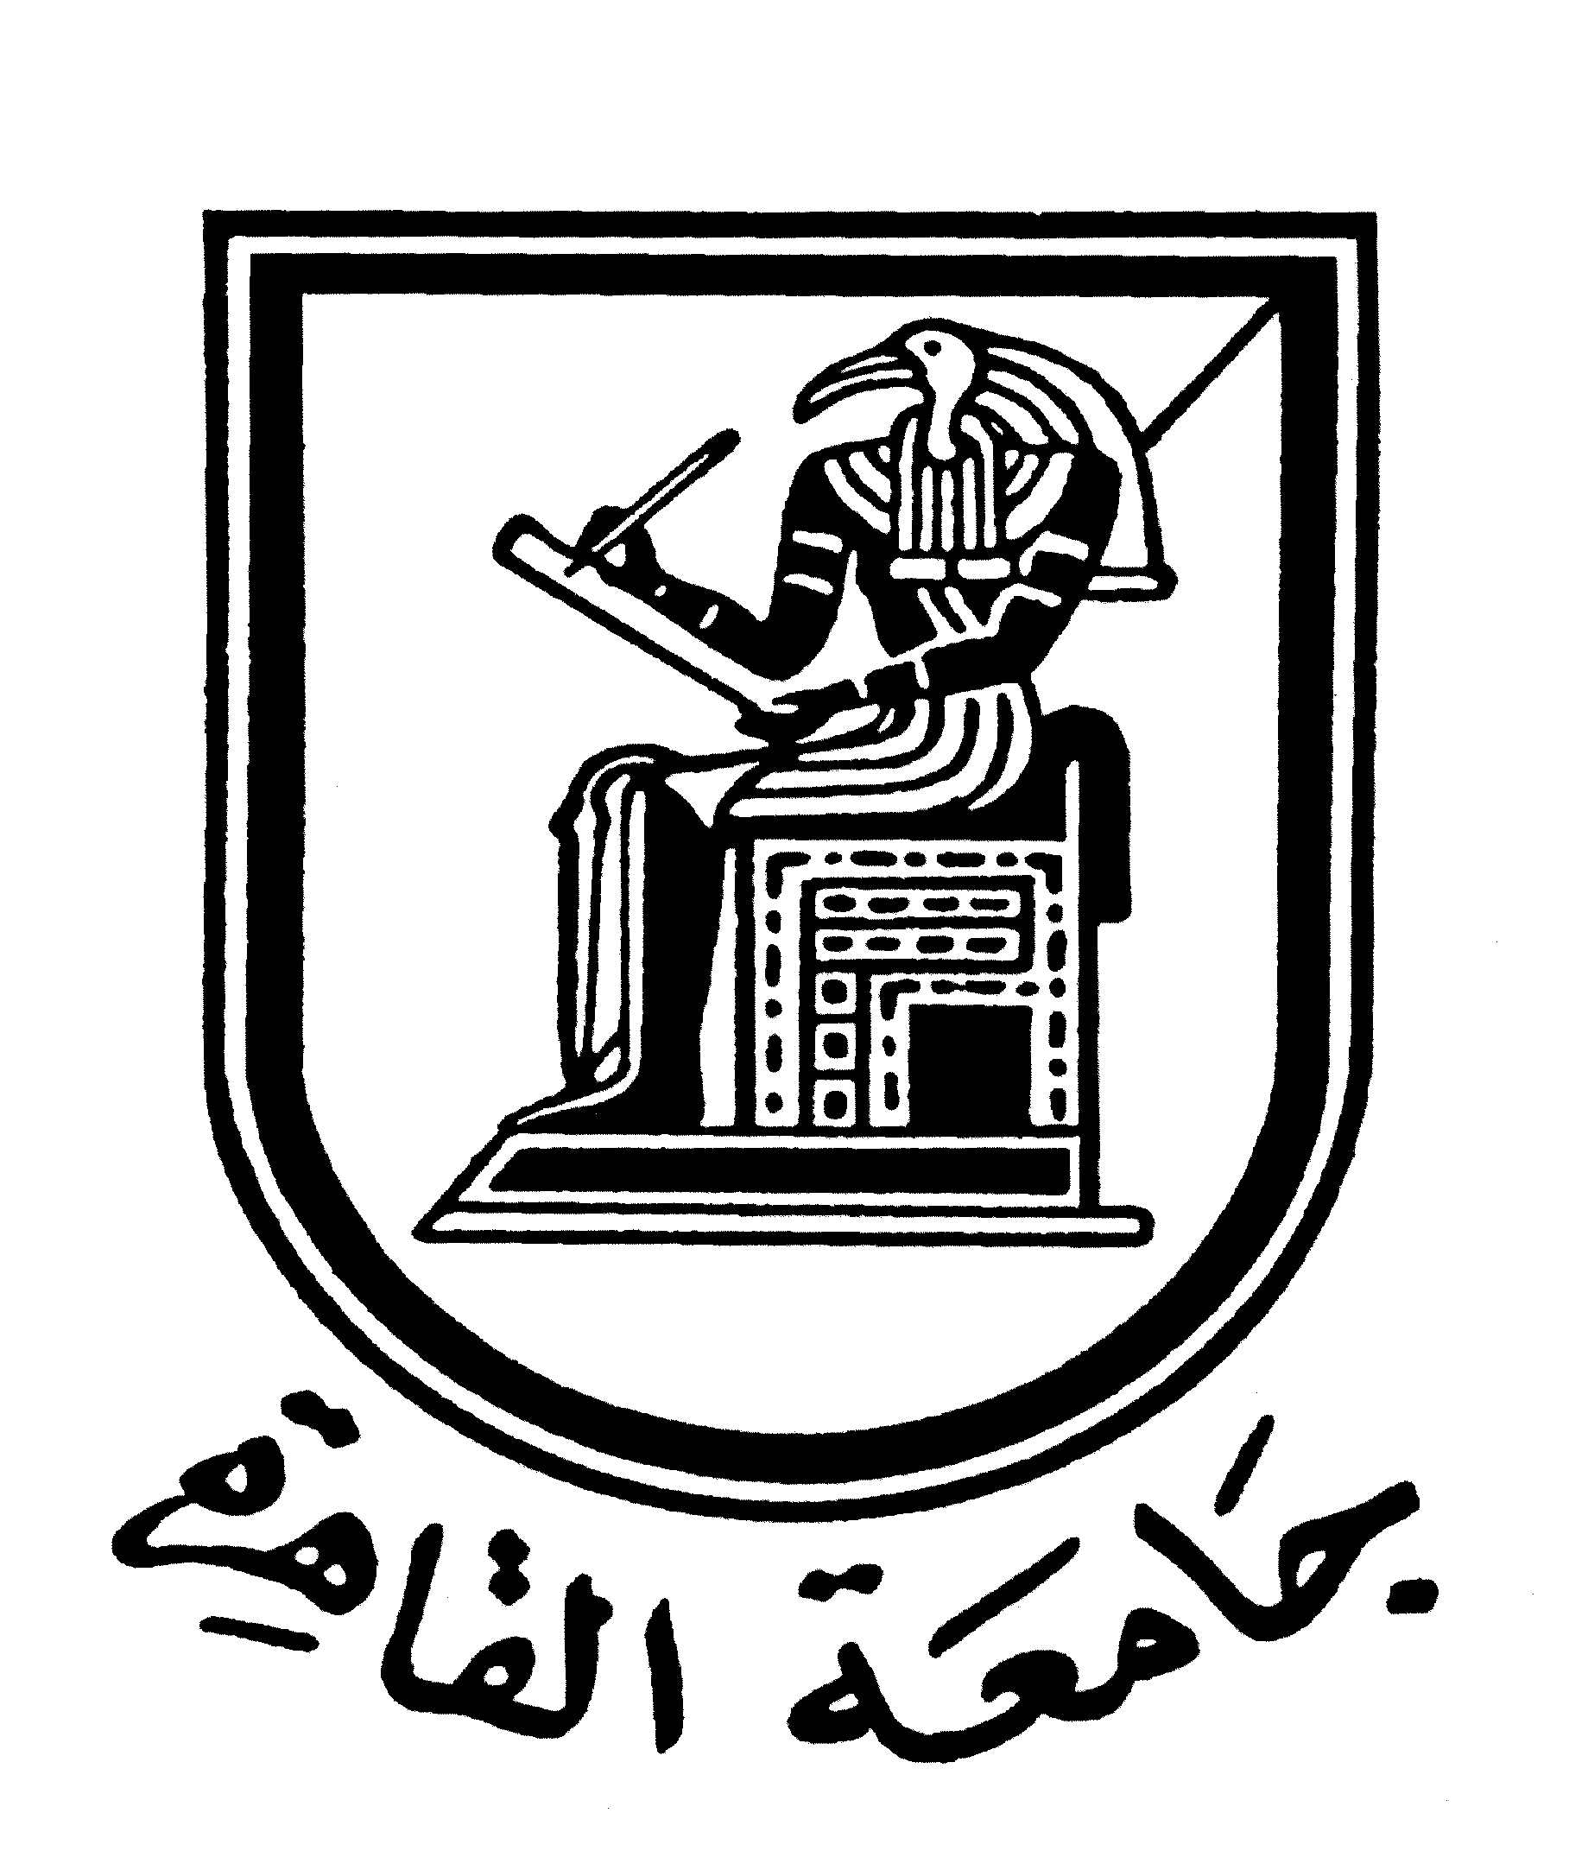 |  | 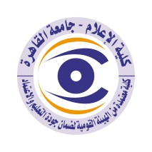

Brief CV (of the members of the academic staff)
- Name: Riham Salah Abd Rabou
- Academic division: Radio and Television
- Academic degree: Teacher
- The title of the master’s thesis, the year and the entity it was obtained from:
- The impact of the use of the internet on the social interaction of the blind, 2015-Cairo University.
- The title of the doctoral thesis the year and the entity it was obtained from:
- The impact of the use of the virtual communities on the Egyptian youth identity-2021-Cairo University

- Courses taught in the Bachelor program:
- Media Research Approaches-Radio & TV Production
- Social psychology of communication
7- The most important reference books issued by the faculty member to benefit from his scientific research (a maximum of five books):

8- The five most recent academic researches that have been published:

9- The most recent five scientific theses (Master's and Ph.D.) that have been supervised:

10- Other activities of the member of the academic staff in order to develop the educational process and serve students other than the teaching activity:

11- The most important leading positions that have been held:

12- The most important local and international awards obtained, the year when awarded and the entity awarded them:

Mobile: 01003008403
Email address:reham.rashed2017@gmail.com

