 |  | 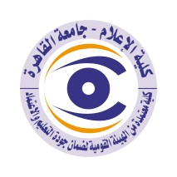

Curriculum Vitae CV (brief) for faculty members
Name: Al-Zahra Ahmed Rashad
Academic Department: Journalism
Academic Degree: Assistant professor
The title of the master's thesis, the year and the authority where it was obtained:
The evolution of basic and social concepts since the January 2011 revolution - an analytical study – 2019
The title of the PHD thesis, the year and authority where it was obtained:
Frameworks for press coverage of women working in sports: An analytical field study in the light of the gender approach (not yet discussed)
Courses you teach in undergraduate programs:
Press translation 1
History of the modern and contemporary world
The most important reference books issued to you benefiting from your scientific research (not exceed five books).
Political and social concepts in the press discourse
The most recent five scientific research published by you:
Frameworks for presenting active women in the field of sports with a sample of general and specialized press sites
The most recent five researches (Master's and Ph.D.) which I have supervised:

The activities you carry out in the college (other than teaching) that contribute to developing the educational process as well as serving students:
Supervising the Sports Department of Sawt Al-Jamaa newspaper - University Journal
The most important academic leadership positions that I held:

The most important local and international awards that I have obtained, the year and the destination of the grants:
Writer Jamal Abu Talib Award for the first journalism department in 2010
Ibrahim Abdo Award for the first journalism department in 2010
Communication means
E-mail:
Mobile:

