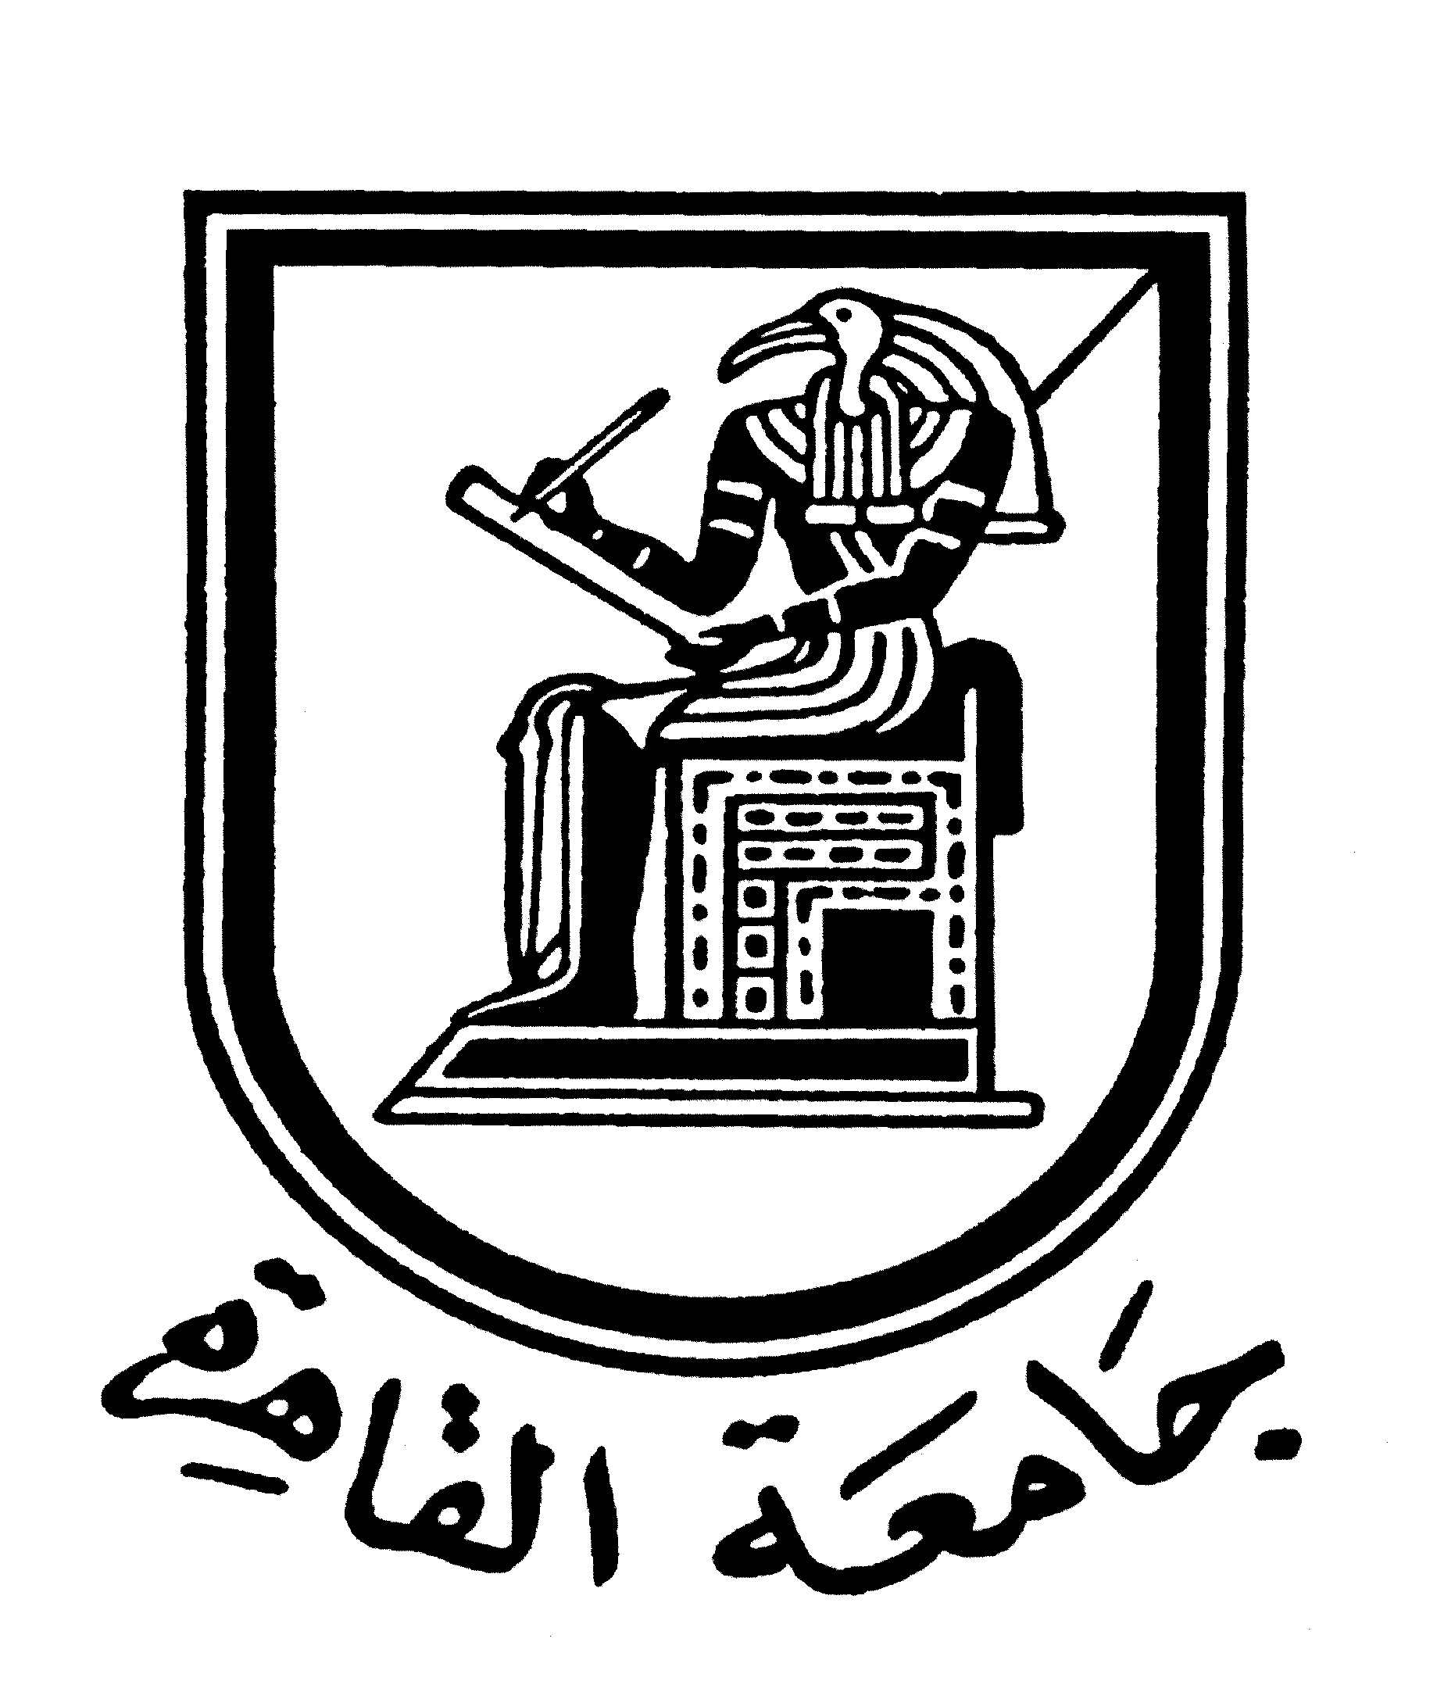 |  | 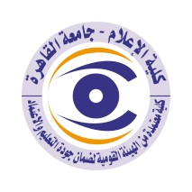

Brief CV (of the members of the academic staff
1- Name: Professor .DR. Hassan Emad Mekawy
2- Academic Department: Radio and Television
3-Academic degree: Full Professor
4- The title of the master’s thesis, the year and the entity it was obtained from:
“The flow of the foreign movies in the Egyptian cinema and television: a study of the content analysis”, 1979-Faculty of Mass Communication- Cairo University.
5- The title of the doctoral thesis the year and the entity it was obtained from:
“Studying the news service introduced by Cairo Radio and compare it with the service provided for the Egyptian Listener by the British Radio Authority”.
6- Courses taught in the Bachelor program:

7- The most important reference books issued to you benefiting from your academic research (no more than five books)
1- The Foundations of Media Research, five editions, Cairo 2019
2- Communication and its modern theories (partnership), 13 editions, Cairo Al Dar Al Masriah al Lubnaniah, 2018.
3- The Technology of Modern Communication in the age of Information, Seven editions, Cairo: Al Dar Al Masriah al Lubnaniah, 2017.
4- The Ethics of Media Work-A comparative study, seven editions, Cairo: Al Dar Al Masriah al Lubnaniah, 2016
5- Radio in the Twenty-first Century (Partnership), two editions, Cairo: Al Dar Al Masriah al Lubnaniah, 2016
8- The five most recent academic researches that have been published:
- Media and Building National Awareness; a research paper presented to the annual conference of the Media and Culture Committees of the Egyptian Writers Union, Media and Building National Awareness Cairo Lined up for printing and distributing the book, first edition 2019.
- Idioms in the media In partnership with the Arabic Language Committee in the media, the annual conference of the Arabic Language Academy in its eighty-fifth session, the Arabic language in modern means of communication, Cairo, March 27-25, 2019.
- The news industry in the twenty-first century: A research paper for the news industry symposium, Cairo International Book Fair, 50th Golden Jubilee, Cairo February 2019.
- The phenomenon of extremism and its repercussions on national security, a media perspective: a study presented to the Military Research Commission, the Ministry of Defence, within the activities of the strategic symposium for the armed forces entitled: The phenomenon of extremism and its repercussions on national security and the forceful confrontation strategies Military Research Commission October 24, 2018.
- A proposed media strategy to confront the phenomenon of extremism and terrorism, a study presented to the Military Research Commission within the activities of the strategic symposium entitled: The phenomenon of extremism and its repercussions on national security and the forceful confrontation strategies Military Research Commission October 24, 2018.

9- The five most recent researches (Masters and Ph.D.) that I supervised:
- The problems of the Egyptian family in cinematic films and their relationship to the level of frustration of the Egyptian public, Faculty of Mass Communication, Cairo University, Ph.D. thesis 2020.
-The image of Egypt as reflected by foreign news channels and its relationship to its image among foreign correspondents in Egypt Faculty of Mass Communication, Cairo University Ph.D. thesis 2018.
-The image of people with special needs as reflected in the television drama and their attitudes towards them - Institute for Arab Research and Studies - Arab Organization for Education, Culture and Science. Master's thesis 2021.
-The role of private Egyptian public radios in shaping the cultural awareness of young people - Institute for Arab Research and Studies - Arab Organization for Education, Culture and Science, Master's thesis 2021.
-The Negative Effects of Social Media on Egyptian Youth - Institute for Arab Research and Studies - Arab Organization for Education, Culture and Science, Master's Thesis 2020.
10- The activities carried out in the faculty (other than teaching) and contribute to developing the educational process and serving students:
- The chairman of Media Graduates Society
- The vice chairman of Egyptian Media Forum.
- The head of Media Committee at the Supreme Council for Culture for the cycles of 2013-2015 and 2015-2017, and the head of the committee at the current cycle 2020-2022.
- Participation in the updating of regulations for studying at the undergraduate and postgraduate levels in the system of accredited hours at the Faculty of Mass Communication, Cairo University 2020.
- Participation in postgraduate programs at the Institute for Security Intelligence Studies in cooperation with the Faculty of Economics and Political Sciences at Cairo University 2020.
11- The most important leading positions that have been held:
- The dean of Faculty of Mass Communication - Cairo University 2011-2014
- Deputy Supreme Council for the Press 2013-2017.
- Rapporteur of the Media Committee of the Supreme Council of Culture 2013-2017.
- Head of the Monitoring and Follow-up Committee for the Egyptian Presidential Elections 2018.
- Member of the Board of Trustees of the Middle East Dialogue Forum - Middle East News Agency 2016.
12- The most important local and international awards obtained, the year when awarded and the entity awarded them:
1- Shield of the Egyptian Writers Union December 2019.
2 - Ahram Canadian Shield December 2019.
3- The Shield of Arab Academy for Science, Technology & Maritime Transport October 2019.
4 - State Prize for Excellence in Social Sciences 2013.
5- Cairo University Shield - Twelfth Flag Day 2013.
Contact means:
E-mail: hemekkawi@yahoo.com
Mobile: 01002666678

